Private Dining Set Menu
Kinross Golf Club
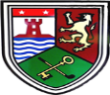
No 1
£13.50pp

Soup of the Day
Garlic Bread

Steak Pie
Mac n Cheese
Lasagne
Salad

Chocolate Fudge Cake
Ice Cream

2 course options
Starter & main £12
Main & Dessert £12.50

