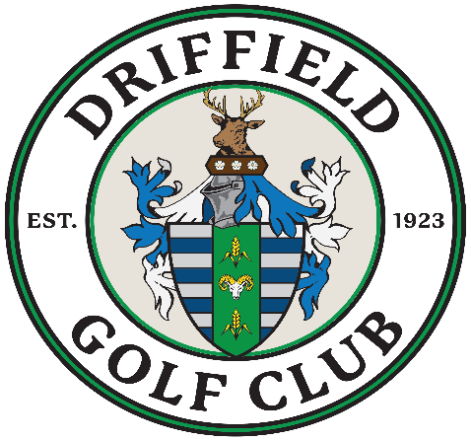
DRIFFIELD GOLF CLUB OPEN AMAM 01.07.19
RESULTS:
1st SCORE / TEAM: 89 R Gray, A Milner, S Anderson, P Sheppard

2ND SCORE / TEAM: 87 D Searby, P Mounfield, P Woodcock, L Ward

3RD SCORE / TEAM: 85 C Fitzpatrick, P Fitzpatrick, M McGing, K Arnold

4TH SCORE / TEAM: 84 (B9 44) K Fitzsimmons, G Longhorn, M Jelic, T Redmore

NEAREST THE PIN 10TH: N Bennett 470cm

NEAREST THE PIN 15TH: M Jelic 10cm

2’S WINNERS:
S Drake, P Mounfield, M Jelic, R Howden, P Thornton, D Skeard, N Smith, C Tyler, P Fitzpatrick, T Diable, M Parker, K Cadwallader, A Minler.

