_______________________________________________________________________________________________
WALTHAM WINDMILL GOLF CLUB
LADIES OPEN
Thursday 24th June 2021

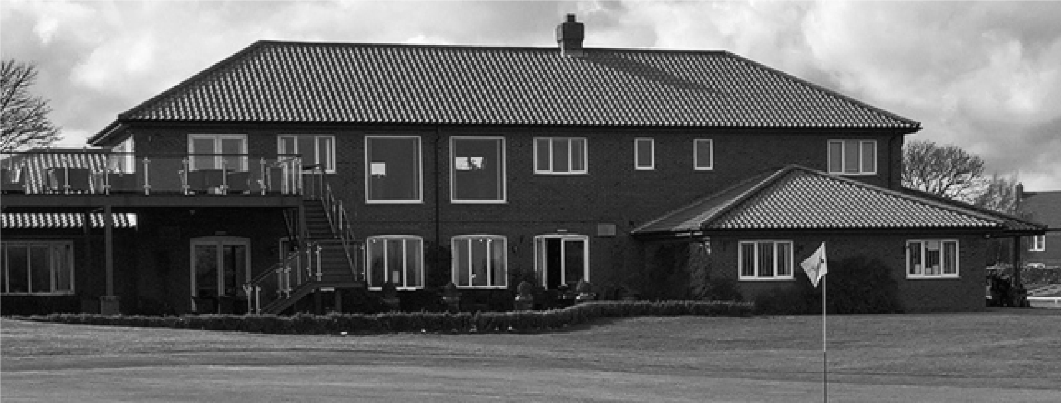

FORMAT
Am/Am Stableford - Teams of Four Players
85% Handicap Allowance
Two scores to count on all holes apart from
14th hole all four scores to count

ENTRY FEE
£96.00 Per Team of Four Players
Includes:
Entry into the competition
Meal after golf
(Choice of lasagne, fish and chips, cold meat salad, vegetarian)
2’s sweep
Halfway house Nearest the pins
_____________________________________________________________________________________
Cheapside, Waltham, Grimsby, DN37 0HT
Telephone 01472 824109
E:mail – secretary@walthamwindmillgolfclub.co.uk

