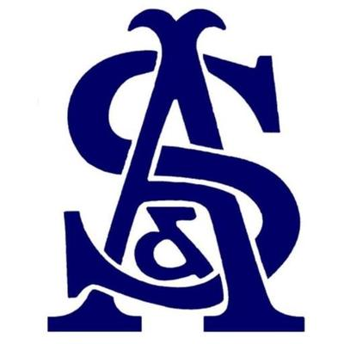

Mixed 4BBB Open 26th April 2021
Results

1st Place - A Gray & R Gray – 46 Points

2nd Place - I McMeeking & S McMeeking – 43 Points (CPO)

3rd Place – S Horner & C Carder – 43 Points

