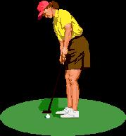
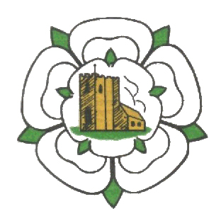
Ghyll Golf Club
Barnoldswick. BB18 6JH
Telephone 01282 842466

LADIES OPEN
AM/AM

STABLEFORD

WEDNESDAY 4th AUGUST 2021

£40 per team of 4
2’s included
85% Handicap – 2 best scores to count

MAXIMUM HANDICAP 40

ENTRY FORM-Ghyll Ladies AM/AM Wednesday 4th August 2021

Players: 1 …………………………………. 2 ………………………………….

3 ………………………………… 4 …………………………………..

Contact email address/postal address and phone number please.

Cheques payable to Ghyll Golf Club Ladies section.
Please send entry form and remittance to:
Susan Taylforth, 4 Birch Hall Road, Earby,
Lancashire. BB18 6JX.
Tel: 01282 843232 email: staylforth@hotmail.co.uk

Winners will be notified and prize vouchers posted.

