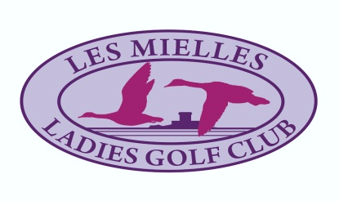
LES MIELLES LADIES GOLF CLUB
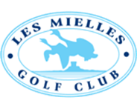
LES MIELLES GOLF CLUB
BRAYBROOKE SALVERS
MIXED FOURSOMES STABLEFORD
THURSDAY OCTOBER 1st 2020
RESULTS

 | LADY |  | GENTLEMAN | H/CAP |  | POINTS
1st | TRACEY BOUGOURD |  | PAUL KING | 15 |  | 35
2nd | HILARY NICHOLSON |  | CHRIS FROST | 15 |  | 33
3rd | MARGARETVAUTIER |  | PETER ROSCOUET | 21 |  | 32
Nearest the Pins
10th HOLE |  | GENT | CHRIS O’CONNOR |  | 4ft 6ins
17th HOLE |  | LADY | ISOBEL BROCKEN |  | 8ft 3ins

16 COUPLES TOOK PART IN THIS COMPETITION
THANK YOU TO THE 32 LADIES AND GENTLEMEN PLAYERS

