Senior Gents Open Sunday 20th June 2021
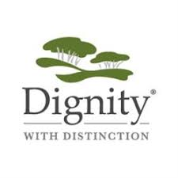
Kindly sponsored by:

Henry Dorricott Funeral Directors,
10-12 London Street,
Larkhall, ML9 1AG
TEL: 01698 882170

Senior gents 18-hole Stableford
Handicap limit 28, Age limit 55 minimum
Forms, entry fee of £10.00 Hollandbush Golf Club, Acretophead, Lesmahagow ML11 0JS. Or Email form & call to pay.
Tel. No. 01555 893484

Hollandbush Golf Club - Seniors Open

Name.............................................................................

E-Mail …………………………………………………..

Age as of 20th June................

Home Club.........................................................................................
Handicap ........................ CDH no…………………….
Preferred Starting Time.....................Phone number………………...

Name.............................................................................

E-Mail …………………………………………………..

Age as of 20th June................

Home Club.........................................................................................
Handicap ........................ CDH no…………………….
Preferred Starting Time.....................Phone number………………...

