New Eco bunkers #Builditonce
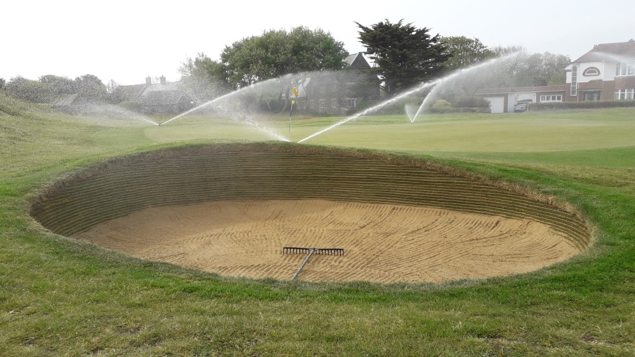
Since the completion of phase one of the bunker improvement programme, various negative comments have been taken on board, reviewed and dealt with. The main gripes being that some bunkers were too deep, the faces were too steep and some were unplayable. The bunkers are in fact shallower, with a slope angle of between 55 and 60 degrees. Slope angles on championship greenside bunkers are 75 degrees.
We all have short memories and forget that it was only last year that the board of Golf Course Management decided to go ahead with a three year bunker renovation programme which would involve the rebuilding of all bunkers using the Eco bunker system. The bunkers at L’Ancresse have been a weak area on the golf course for a number of years.
After a recent visit from Llewellyn Mathews (construction manager for Eco bunker) to review the finished bunkers and to look into the various problems that were bought to the boards attention. Firstly Llewellyn congratulated the team on a successful project, producing some top quality work in what was a mammoth task to rebuild fifteen bunkers in the timescale given.
Secondly we spoke about how bunkers have evolved over the years and how the maintenance and in particular how the raking has moved on. We discussed at length about the issues at L’Ancresse and how other courses had experienced similar problems.
Llewellyn recommended some minor changes in the way we rake the bunkers and also proposed improving the quality of the rakes. He suggested that flat raking the edges further up the bunker face would take away the resistance and allow the golf ball to roll further into the bunker a method that is now used on many courses including Royal Portrush and more recently Gleneagles. The base of the bunker will still be raked with the teeth to provide a fluffy surface and to allow the club to slide under the golf ball.
New rakes have been purchased and have been introduced to all of the new bunkers, these rakes will be added to the rest as they are completed.
Below are a sequence of photos showing the new rakes and how the bunkers will be raked.
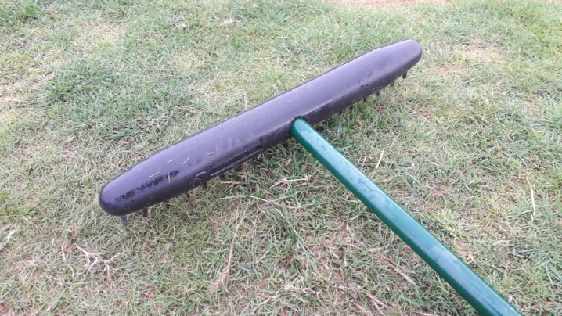 | 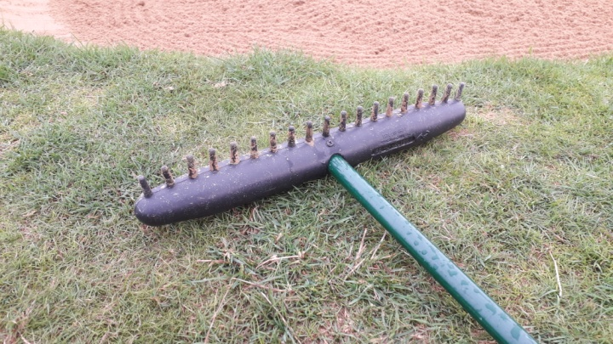
The new rakes have a torpedo shape which allows you to flat rake and rake using the one rake. It is hoped in time that the members will also improve their method of raking and provide a well raked bunker for those following behind.
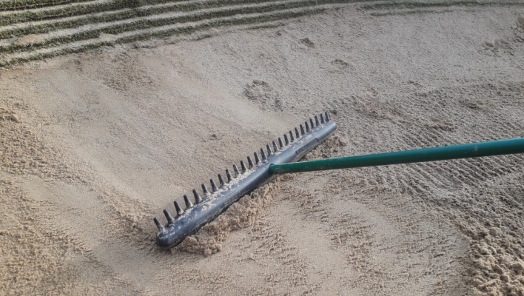  Flat raking the edge of the bunker using the smooth side of the rake. | 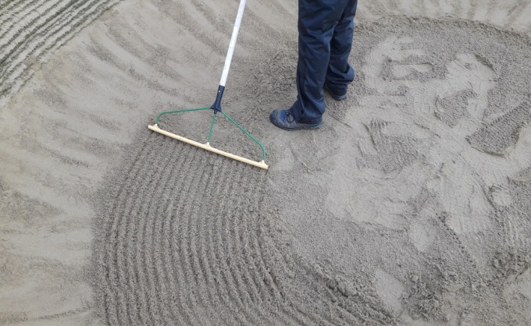  Marking out the raked edge in the base of the bunker.
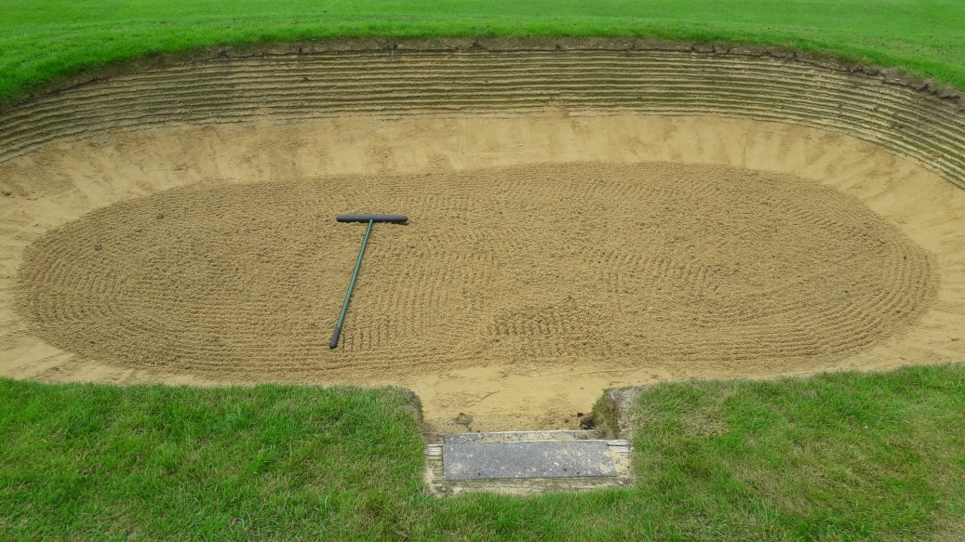
A completed bunker waiting for its first victim.

