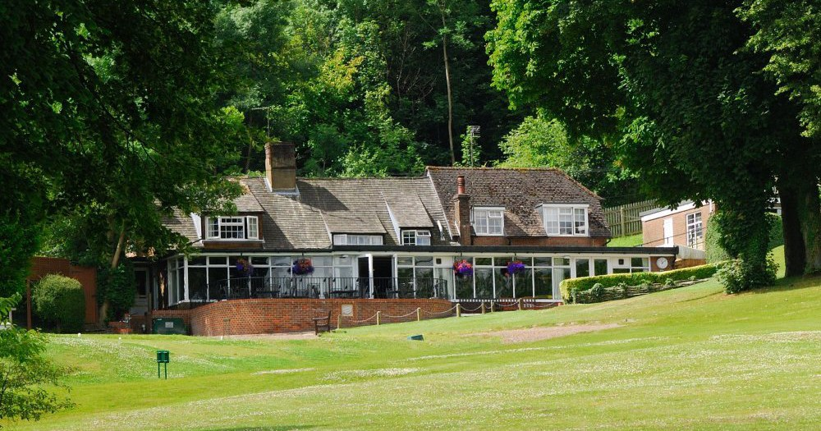
WHITELEAF GOLF CLUB
COME AND ENJOY OUR HOSPITALITY AND PICTURESQUE COURSE

LADIES COFFEE MORNING AND GOLF
TEAMS OF THREE
THURSDAY 1 SEPTEMBER 2022
Maximum Handicap Index 36
£19.95 per person to include Tea/Coffee
and Danish Pastry on arrival and 18 holes of Golf

Should you wish to stay for lunch afterwards a varied bar menu will be available.
Please complete and return the entry form below

1st Name.......................................... Club..........................................................

Tel ................................................. Email........................................................

2nd Name......................................... Club..........................................................

3rd Name.......................................... Club..........................................................

Please return to Sue Wakefield, Admin Secretary
Whiteleaf Golf Club Ladies Section,
Upper Icknield Way, Whiteleaf, Princes Risborough, Bucks HP27 0LY
Cheques should be made payable to: WGC Ladies Section

You will be notified of your tee time by email

