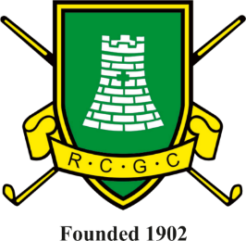
To book your Society Day,
please contact:
Ange Goater
Office Administrator
On 023 92412784 or
admin@rowlandscastlegc.co.uk

** Societies available on Tuesdays and Thursdays Date Deposit** Received:
SOCIETY NAME |  |  | ->
ORGANISER'S INFORMATION
 | Name |  | ->
 | Email Address |  | ->
 | Phone Number |  | ->
REQUIREMENTS
DATE AND TIME
 | Preference |  | ->
 | Alternative choice |  | ->
GOLF |  |  |  | ** Texas Scramble formats are not available at this time.
 | Number of golfers |  | ->
 | 18, 27 or 36 holes? |  | ->
 | 3 or 4 ball format |  | ->
 | Tee times preferred |  | ->
 | Number of buggies? |  | ->
 | Markers |  | ->
 | Nearest the Pin |  | ->
 | Longest Drive |  | ->
FOOD |  |  |  | ** If eating prior to golf, food will be served one hour before the first tee-time.
 | Morning food choices |  | ->
 | For how many? |  | ->
 | Afternoon food choices |  | ->
 | For how many? |  | ->
 | Evening food choices |  | ->
 | For how many? |  | ->
 | Special Dietary Reqs |  | ->

Please send your deposit via BACS to: Sort code 30-93-97
Account no. 00239335

Alternatively, please send a cheque payable to Rowlands Castle Golf Club.

Thank you for choosing Rowlands Castle Golf Club for your Golf Society day.

** Please note, receipt of the non-refundable deposit will secure your Society’s booking.

