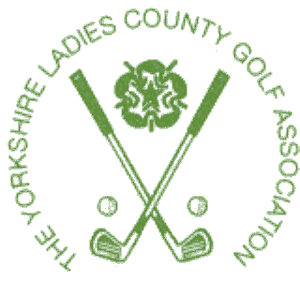
YORKSHIRE LADIES’ COUNTY GOLF ASSOCIATION
YORKS MID-AMATEUR TEAM v YVLGA 1st TEAM
OAKDALE GOLF CLUB ON SUNDAY 18th APRIL 2021

TEAM
YVLGA  1ST Team | Score | Pts | YLCGA  Mid Am Team | Score | Pts
1 Angela Morris  Karen Jobling | A/S | ½ | Helen Barugh  Cath Lake | A/S | ½
2.Bet Sworowski  Sandra Paul | 2& 1 | 1 | Heather Butcher  Jayne Helliwell |  | 0
3.Julie Wheeldon  Carol Simpson | 4&2 | 1 | Katie Barraclough  Carla Pawson |  | 0
4.Elaine MacGregor  Fiona Wood |  | 0 | Patsy Rochester  Julie Parry | 3 &1 | 1
5. Tracey Batty  Tracey Maddison |  | 0 | Kerry Lamb  Ruth Suffell | 4 &2 | 1
RESULT |  | 2 ½ |  |  | 2 ½

A splendid sunny day with the match being played in very good spirits

