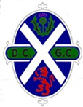
COMPETITION RESULT

EVERGREEN TROPHY 2021

WINNERS
D MACDONALD & D YOUNG (D&C) 41pts

2ND
C PREACHER & A PREACHER (Carnwath) 39 pts

3rd
R Fraser & J Fraser (D&C) 38pts

4th
S DUDSON & L DUDSON (Penrith) 37pts (last 6)

