Golf should be fun!
You should feel safe and enjoy your sport

Is something worrying you?
Do you need someone to talk to?

Speak to your club welfare officer
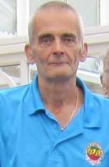

Your Club Welfare Officers is:

Mick Painter

Email address: painmic@aol.com

Telephone Number 01773 718368

Alternatively, you can speak to someone at

ChildLine 0800 1111 | NSPCC 0808 800 5000 | England Golf 01526 351851

