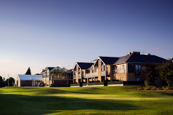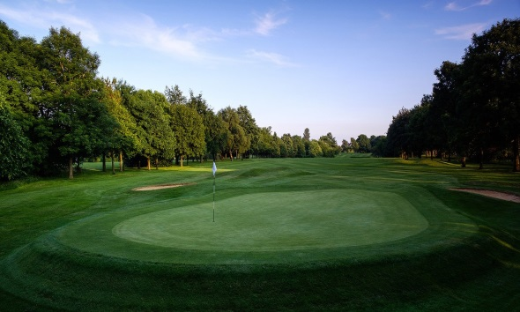
Golf Package 2 night’s accommodation
3 Rounds of Golf
The Golf Course
Parkland 6284 yards, 18 hole, par 72 golf course boast immaculate greens all year round, tree-lined fairways and a warm welcome to visitors, societies and hotel guests.
Voted one of the Top 3 Golf Courses in Oxfordshire and are one of, if not the oldest golf clubs in Oxfordshire having been established over 100 years ago.

BOOK Early to avoid disappointment
Top prize -
Brand new Taylor Made driver worth over £300

Contact any Foxes Member if you want to come to next year’s Foxes Event
Cost £219 sharing or
£299 for single accommodation

