Advisory Route for Buggies.
Golfers who use buggies should in the first instance follow the guidance given in the Club Buggy policy and Health and Safety policies. The course has a number of paths and roadways for the use of golfers, these should also be used by buggies wherever possible. The course plan should also be consulted when using a buggy. A suggested route for buggies is:
Hole 1
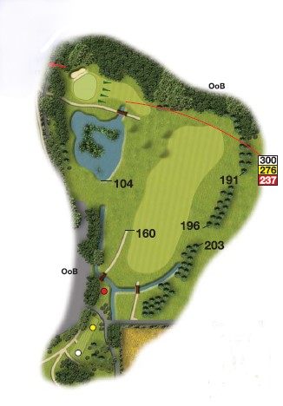
The tee is accessed from the car park and is a wide hard path. You may need to turn your buggy at the halfway house area. On leaving the tee the fairway is accessed along the pathway in front of the ladies tee. The fairway is slightly sloping, and you should drive straight across it. To the left is a steep slope descending towards a deep pond. This slope is not suitable for buggies. The green area is accessed by crossing the footbridge, it is wide for buggies and this pathway should be used. The slope to the right and pond to the left are not suitable for buggies. Exit the green area by following the path, care should be taken crossing the lane as well as observing golfers teeing from the right on the 18th tee.

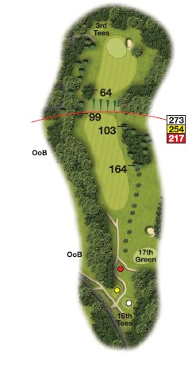

Hole 2.
The tee is elevated. A path leads down to the left towards the fairway but is for walkers only. Buggies should follow the road behind the tee descending with care as the slope is steep to the back of the 17th green where they can access the path to the 2nd fairway. Beware of oncoming traffic when using this path. The fairway is initially slightly sloping and suitable for buggies at this point. On reaching the cross-slope buggies must keep left towards the large tree to access the elevated green. Under no circumstances must buggies attempt to use the steep slope. Buggies should keep to the left of the green to access the 3rd tee.

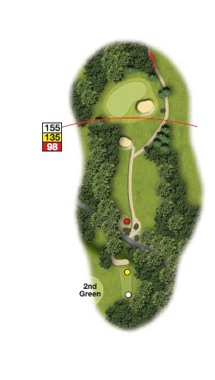
Hole 3.
To the left of the 2nd green a bell is provided to inform following players that you have safely left the green area. Exit the tee to the left using the designated path for a buggy and not the steeper walk path which has a post to obstruct this movement. This gives access to the entrance road and you should turn right, take care to ensure the road is clear of vehicles when you do this. A path runs along the centre of the short fairway, you should veer right to access the path on the 4th fairway, moving left behind the green. Beware of stray tee shots. There are two bunkers around this green.

Hole 4
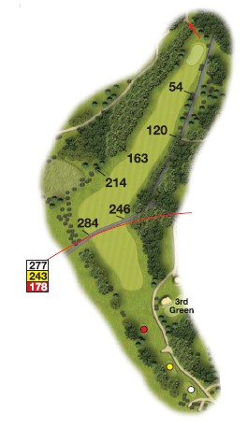
The tees are accessed easily by the path from the back of the 4th green. You will need to turn the buggy around. Leaving the tee you descend slightly downhill turning right towards the green. There is no path, but the fairway is easy to negotiate. To the left of the fairway is a wooded dell which buggies cannot access, at the green side this opens out into a steep lateral slope with water at the bottom. The right side of the fairway is bounded by the entrance road, posts prevent use of the road by buggies. Buggies should park in front of the green ready to turn left. On leaving the green there are two paths, you should generally use the one in front of the green which is a sloped wide path that leads to the 5th tee. Care should be taken as players teeing off from the 8th tee may not be aware of your presence. A second path may be used, it leads from behind the green and is accessed from the main roadway. It is steep and care should be taken when ascending and also beware of players teeing of from the right.
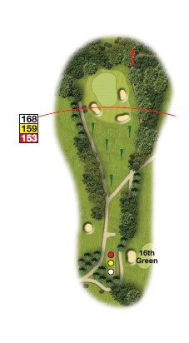
Hole 5
A short uphill hole with paths to either side. Buggies are advised to use the right-hand path as the left has the additional hazard of a ditch at the side. There are 3 bunkers around this green. Park on the right ready to access the slope to the 6th tee.

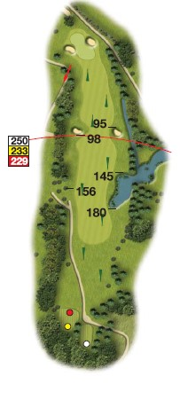
Hole 6
On leaving the 5th green the path ascends steeply uphill to the 6th tee. There is a drop to the right of the path so care is needed. From the 6th tee the path is central but bears left. Be aware to avoid a deep ditch on the left of the path as well as a large deep pond on the right. The fairway is initially level then descends downhill to the green. There is now a ditch to the right. Buggies should stop before the green avoiding the bunkers as well as a steeper slope to the left side.

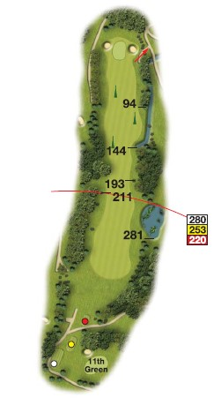
Hole 7
The tee is slightly above the 6th green and care should be taken use the path. On leaving the tee the fairway is even until the midway point where it narrows and then descends to the green. Hazards include a large pond on the right an elevated bank on the left and a ditch in front of the trees on the left. When descending the slope take care although it is a relatively slope, care to avoid the ditch to the right of the fairway. At the green keep right avoiding one of two bunkers ready to access the 8th tee.

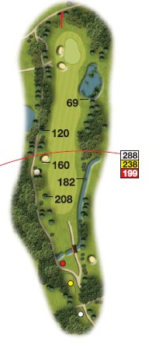
Hole 8
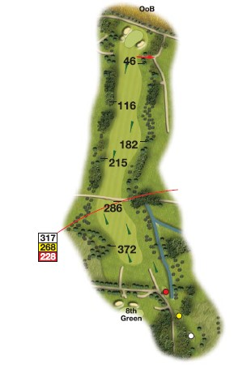
The reverse of the previous hole. The tees are accessible slightly downhill by using the path, you will need to turn the buggy. Returning uphill, crossing the bridge to avoid the cross ditch which continues on the right as you ascend the fairway. At the top of the hill the fairway levels out but take care to avoid the bunker on the left with a hidden pond further across. A roadway may be used here to drive towards the green. On approaching the green there is a large deep pond with steep sloping sides, buggies should keep well to the left of the green passing around the deep bunkers to access the path at the back of the green.

Hole 9
A path to the tees is goes from the back of the 8th green. On leaving the tees the path slightly slopes and joins the even fairway descending until it crosses a small road where care is needed as the bank is steep in some areas. There are ditches to the right and left at this point, do not attempt to cross the ditch on the right using a buggy even if it appears to be not deep in places. The fairway ascends gently uphill to the green where a path on the right will take you to the next tee. There is a slope to this green and a bunkers to the left and right.
Should you wish to leave the course at this point take the path on the left which descends past the 1st tee to the car park.

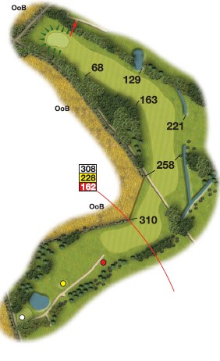
Hole 10
The path from the tee leads to a downwards sloping fairway which crosses the road before ascending uphill. On the right the slope is unsuitable for buggies, use the central fairway which ascends turning left and then levelling out. A ditch joins from the right before entering the trees, then meets a small pond. The fairway is level at this point to the green. You should approach and leave the green on the right hand side to access the path to the 11th tee. Buggies should not go behind the green as it is steeply sloped.

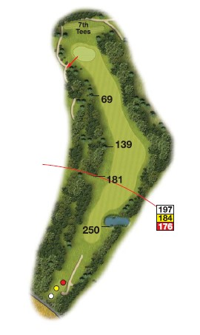

Hole 11
From the tee there is a short path before a dog leg fairway leading to the green. When leaving the path a deep pond is on the right side. The green should be approached from the left side where there is a slight slope. However, avoid the rear of the green which is steep sided.

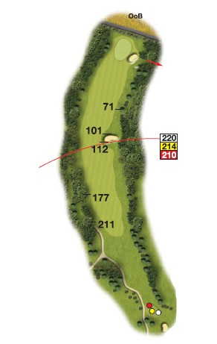

Hole 12
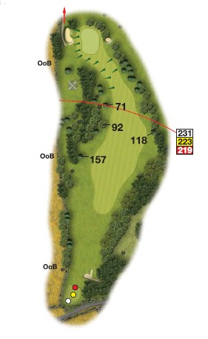
From the left side of the 11th green join the path in front of the tee turning left. The path leads from the tee along the left side of the fairway allowing access to the fairway. Take care to avoid a wide bunker on the right behind which in the trees there is a deep ditch. He green is flanked by a small elevated mound on the left and a bunker to the right. Leave the green to the right using the path which crosses the ditch.

Hole 13
The path from the 12th is straight and at the tee you should turn right. From the tee a short path lead to the fairway which is gently sloping to the left. The green is slightly elevated, and buggies should keep left of the green and avoid the slope and bunker to the right. This leads to a path around the green and bunker.

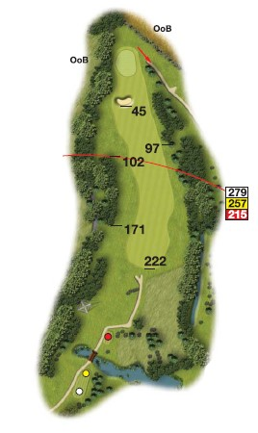
Hole 14
The path from the 13th green leads behind the 6th green with a deep ditch on the left side before moving uphill to the next tee. When leaving the 14th you should carefully cross the wide bridge, avoiding two ponds on either side. The path winds a little and gains the fairway which slopes gently uphill towards the green in the corner. A bunker guards the access to the green and you should keep right passing in front of the trees to regain the path at the rear of the green. Turn right at the end of the tree line to access the next hole.

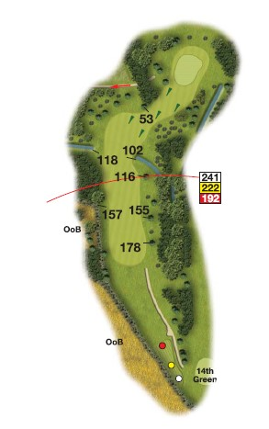
Hole 15
From the tee the path leads to a steep downhill fairway levelling off before ascending to the right to an elevated green. On the left of the fairway there is a pond and small ditch. On the right a ditch emerges from the trees to intrude slightly into the fairway. The green is quite elevated, the slope unsuitable for buggies and you should park on the left by the bell.

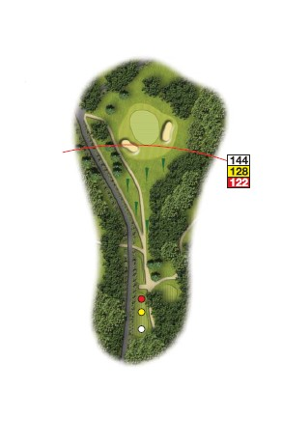

Hole 16
Leave the 15th green from the parking area using the downhill path, turning left to the tee area at the bottom. From the tee the path continues down the short fairway sloping gently to the right of the green. The left side does not have a path and around the green the bunker is heavily sloped. You should follow the path and keep right towards the green. Do not go behind the green where there is a steep slope and a wide ditch.

Hole 17
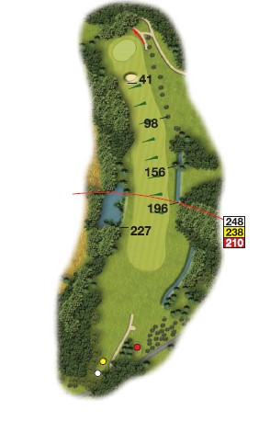
From the 16th follow the path around the corner taking care to avoid a small ditch. At this point you approach the 8th tee and should beware of players who may be teeing off. At this point the path descends sharply downhill. Large buggies must use this path, but small buggies may utilise the more winding but less steep path on the right. At the bottom of the slope there is a pond and the path continues uphill crossing the entrance road, give way to traffic. From the tee a path ascends to the crest where the fairway descend, a buggy may spot from here. Buggies should keep right as far as possible as the slope to the left can become quite steep. If it is wet some areas can be quite slippy and you should ensure that you remain in control of the buggy. The woods to the right are bounded by a ditch which runs along part of the fairway into the trees. To the left of the fairway is a small lake from which a stream extends through the wooded area to the left as you approach the green. The fairway is slightly sloping but easily passable keep to the right of the bunker to join the path around the green. This crosses a ditch and allows you to gain the path at the rear of the green. Avoid the left side of the green as the mounds lead to the stream and a small pond.

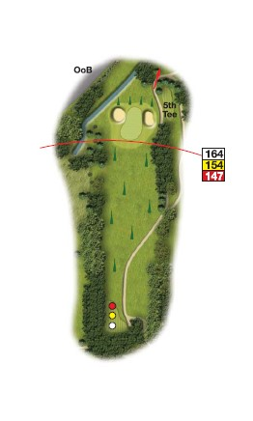

Hole 18
From the back of the 17th green cross the ditch before ascending uphill. The path was used when you started the round so beware of traffic coming in the opposite direction. From the tee the path moves uphill, you should use the main path rather than the lower level path. Do not go too far right as there is a drop into the wooded area. It is possible to drive behind the bunker and green to carefully re-join the path, take care as there is some degree of slope and the path does have an edge which should be avoided. Ideally keep left on the main path.

Leaving the course is straightforward continue forwards along the path to join the main entrance road close to the gates. Take care of traffic on this road, look right before emerging. The entrance gates may be closed but will open automatically as the buggy is driven slowly towards them.

If you have rented a buggy, please park it in the designated area. Return the keys to the club shop. Please also ensure the buggy is returned clean and tidy. If there are any incidents or damage inform the course manager.

