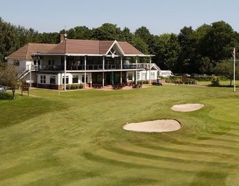

NEVILL JUNIOR OPEN
Thursday ^{25th} AUGUST – FIRST TEE TIME 10am
18 HOLE MEDAL –WHS 0-18 Boys & Girls (mixed)
18 HOLE STABLEFORD – WHS 19-28 Boys & 19-36 Girls

Under 18 Years of age on 01.01.2022

PRIZES
Scratch 1st & 2nd, Nett 1st & 2nd + Nearest the Pin and Longest Drive

ENTRY WILL BE CLOSED AFTER FIRST 60 PLAYERS
CLOSING DATE FOR ENTRIES: Thursday 18th AUGUST ( Reserve list strictly in order of application)
(No Caddies or spectators are permitted, viewing areas only)
ENTRY FEE £27 (MEMBERS £20) to include meal plus drink after competition ends and before Prize Giving
……………………………………………………………………………………….

BLOCK CAPITALS PLEASE
FULL NAME: DATE OF BIRTH: AGE: GENDER
ADDRESS:
COUNTY: P/CODE: MOB NO:
EMAIL ADDRESS:
GOLF CLUB: HANDICAP INDEX (0-28 Boys, 0-36 Girls):
CDH ID: Competitor’s Signature:
All entry forms and profiles must be sent to annabelbuckland@hotmail.com 07717384949
All entrance fees must be sent to the club by BACS or cheque

PAY BY BACS TO: NEVILL GOLF CLUB
Account Number: 10808092
Sort Code: 40-51-62
Please ref - Junior Open plus surname

PAY BY CHEQUE TO:
Nevill Golf Club (Junior Open)
Benhall Mill Road
Tunbridge Wells
TN2 5JW

PLAYER PROFILE
CHILDS NAME:
EMERGENCY TEL NO: 07762558187
Please list any ailments, allergies or disabilities that NGC should know about both on the course and in the clubhouse:
Medical –
Dietary requirements -
For in depth information on ‘Safeguarding Children’ at the NGC please check our website, Important to read the following: -

APPX. 10 JUNIOR PROFILE & PARENTAL CONSENT FORMS
APPX. 11 PHOTOGRAPHY CONSENT
APPX. 12 GUIDANCE TO PARENTS

Please ensure a Parent, Carer or Appropriate Adult picks up your child from the NGC once the events of the day have concluded.

Any questions before or on the day please contact our Welfare Officer, Richard Wilson 07570 584191 or rwilson9532@gmail.com

