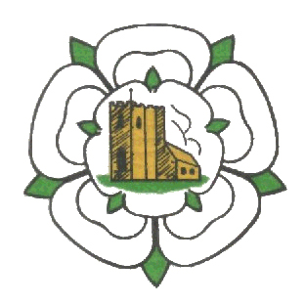

Ghyll Golf Club Barnoldswick
Ghyll Brow, Skipton road, Barnoldswick BB18 6JH Tel. 01282 842466
MIXED OPEN
4 Ball Better Ball Stableford
Sunday 4th July 2021
£20-00 per couple
85% Handicap Allowance
Maximum Handicap Index Men 24, Ladies 36
Tee Times 10:00 to 12:00
Please email Colin Maud on
colinmaud85@yahoo.com or ring on 07764339046
with Names, Club, Handicap Index & preferred Tee time for
confirmation of tee time and payment options.

