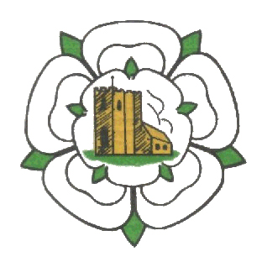
Ghyll Golf Club Barnoldswick
Ghyll Brow, Skipton road, Barnoldswick. BB18 6JH Tel. 01282 842466
4 Man Team Open
Sunday 5th September 2021
£40 per Team from White Tees, 2’s included
Stableford - Maximum Handicap Index 24
90% Handicap Allowance.
2 to score front 6, 3 to score mid 6 & 4 to score back 6
Tee times 08:00 to 09:30 & 12:00 to 13:30
Please email Dan Inman danielinman1234@gmail.com or ring on 07805984551 with Names, Club, Handicap Index & preferred time for confirmation of tee times and payment options.

