***Christmas***



***Dance***

Saturday 14th December

***Evening Entertainment by…***

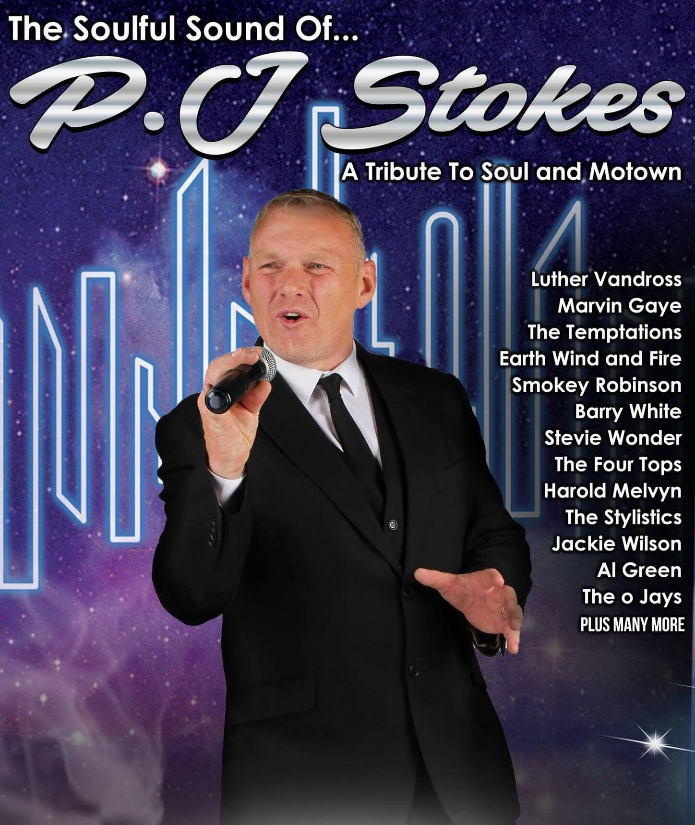

**Starts 8.00pm**

**Late Bar**

**Tickets £5**

**Dress Code: Smart Casual**

**Sandwiches available to order in advance of the evening**

**from behind the bar.**

To reserve your place please put your name down on the list on the main lounge notice board. Payment is required to the Secretary’s Office in advance

by no later than Friday 6th December.