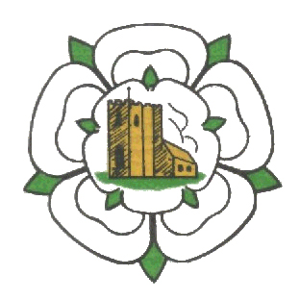
Ghyll Golf Club Barnoldswick
Ghyll Brow, Skipton road, Barnoldswick. BB18 6JH Tel. 01282 842466
SENIORS OPEN
4 Ball Better Ball Stableford
Tuesday 6th July 2021
£20-00 per pair, Including 2’s
Maximum Handicap Index Men 28
Age Limit 55+ (Yellow tees)
85% Handicap Allowance
Tee times 08:00 to 09:30 & 12:00 to 13:30
Please email Stephen Morrissey on stephenandjanet78@gmail.com or ring on 07377548971
with Names, Club, Handicap Index & preferred time for
confirmation of tee times and payment options.

