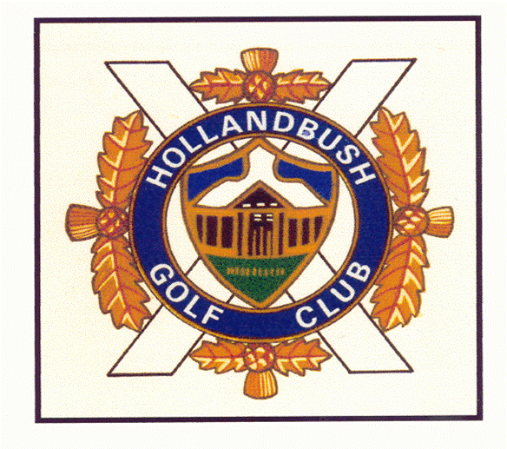**1555 89364**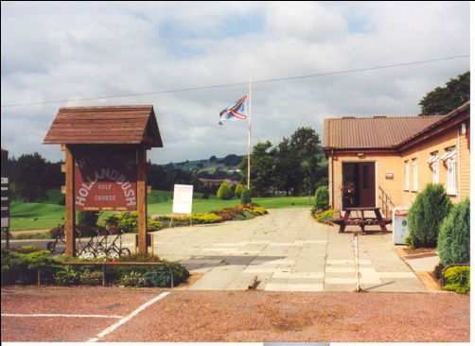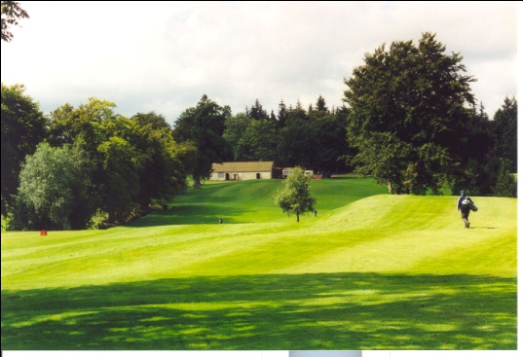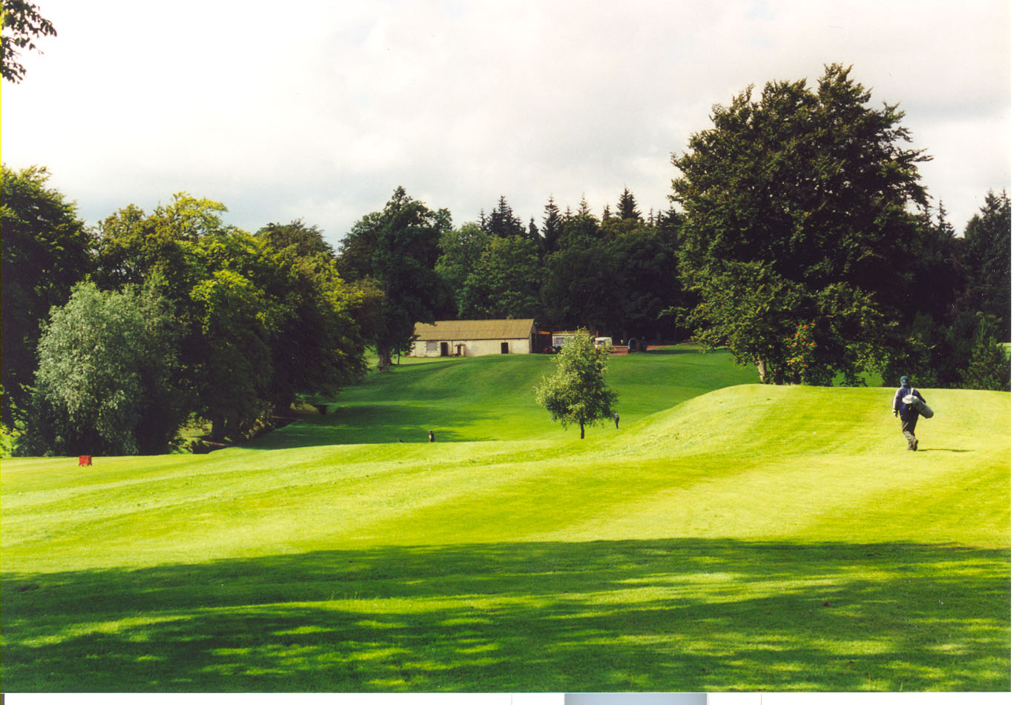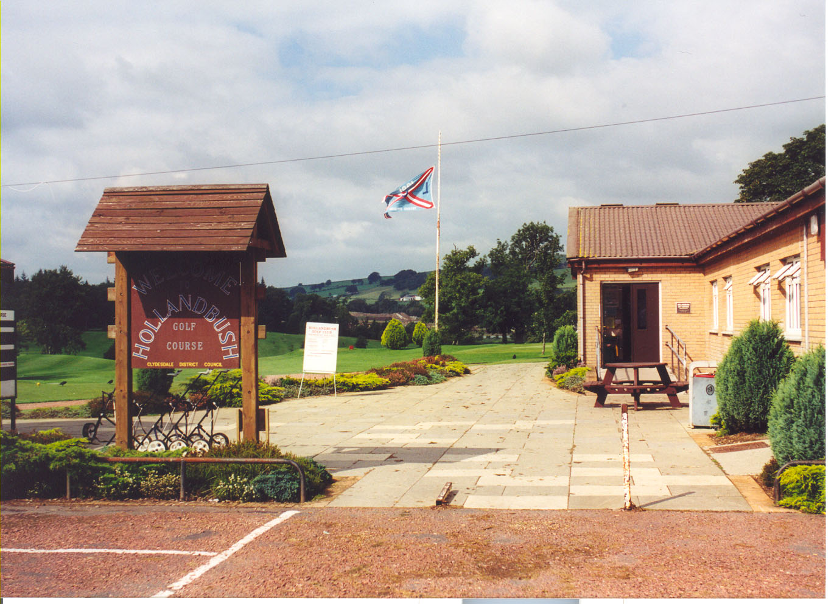

**Email:**

[**mail@hollandbushgolfclub.co.uk**](mailto:mail@hollandbushgolfclub.co.uk)

**for more info or to book**

**Breakfast roll, Round of golf,**

**2 course dinner**

Monday –Friday £25

Saturday –Sunday £35

Why not consider bringing a group to one of our open competitions?

Have you booked your golf outing yet?