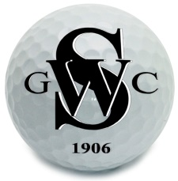
Stanton-on-the-Wolds Golf Club

COMPETITION RESULT

Spring Mixed Open

21st May 2023

Spring Mixed Open Top 6
 | Competitors | Score | Playing Handicap | Count Back
1st | Stephen Cammack & Sue Clarke | 45 | 9/19
2nd | Stuart Clarke & Keri Clarke | 44 | 9/17
3rd | Di Sully & Patrick McGovern | 43 | 24/12 | L9 – 22  L6 – 16
4th | Neil Wilkinson & Jean Wilkinson | 43 | 9/22 | L9 – 22  L6 – 14  L3 – 7
5th | Warren Carr & Jo White | 43 | 2/19 | L9 – 22  L6 – 14  L3 – 6
6th | Simon Morris & Helen Morris | 43 | 13/20 | L9 – 21

Competition and Handicap Secretary 22nd May 2023

