^{Golf Club Bar Menu}
Breakfast Cold Sandwiches White/Granary
Egg Bap £2.00 Cheese/ Cheese & Pickle £3.80
Bacon/Sausage Bap £2.50 Ham £4.80
Bacon & Sausage Bap £3.50 Chicken £4.80
Toasted Teacake £1.30 Tuna Mayonnaise £3.80
Home-made Fruit Scone £1.50 Brie & Grape £4.80
Home-made Cheese Scone £1.80 Prawn & Marie Rose £4.80
With Salad Garnish & Chips
Hot Box Toasties & Paninis Toastie Panini
Home-made Soup £3.50 Cheese/Onion/Tomato £4.70 £5.00
Soup & Sandwich £5.50 Brie & Cranberry £4.70 £5.00
(Ham, Tuna or Cheese) Ham & Mozzarella £5.00 £5.50
Cheese on Toast £4.00 Tuna & Cheese £5.00 £5.50
With Salad Garnish Brie/Bacon/Cranberry £5.00 £5.50
Sausage, Egg & Chips £5.50 Sweet Chilli Chicken £5.00 £5.50
Battered Chicken Goujons £6.50 Chicken/Bacon/Mayo £5.00 £5.50
Served with Salad & Home-made Hunters Chicken £5.00 £5.50
Chips & Real Ale Chutney With Salad Garnish & Chips
Battered Salmon Goujons £6.50
Served with Salad & Home-made Salads
Chips & Sweet Chilli Sauce Ham £6.00
Salmon & Cod Fishcakes £6.50 Chicken £6.00
Served with Salad & Home-made Chips Prawn & Marie Rose £6.50
Served with Homemade Chips or Crusty Bread
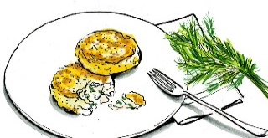

Hot Baguettes Jacket Potatoes
Cheese/Bacon Melt £5.50 Cheese £5.00
Pan Fried Minute Steak £5.50 Chilli £5.00
With Onion & Garlic Chilli & Cheese £5.50
Brie/Bacon/Cranberry £5.50 Tuna Mayonnaise £5.00
BLT £5.50 Prawn & Marie Rose £5.50
Chicken/Bacon/Mayo £5.50
Southern Fried Chicken £5.50 Something A Bit More
With Garlic Mayonnaise Chilli Con Carne £6.00
Served with Salad Garnish & Chips With Rice/Chips or Both
Battered Fish & Chips £7.50
Bratwurst & Fried Onions £4.50 Served with Mushy Peas
With Curry Ketchup/ Breaded Scampi £7.50
Mustard Mayo & Coleslaw & Chips Served with Garden Peas or Salad & Chips
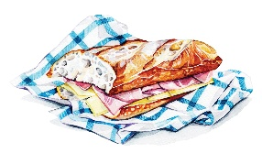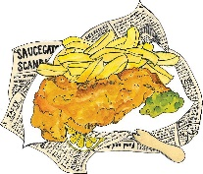

Omelettes Chicken Curry £7.50
Plain Omelette £4.50 With Rice/Chips or Both
Ham 80p Savoury Mince £6.50
Bacon 80p With Yorkshire Pudding
Cheese 80p Steak ‘n’ Ale £8.00
Onion 80p With Shortcrust Pastry Top
Tomato 80p Vegetarian Special £7.00
Mushrooms 80p
Served with Salad & Home-made Chips
Due to the coronavirus situation we are working with reduced staff and slightly reduced menu.
All our food is still freshly cooked to order, we would appreciate your patience through this time.
Please advise staff of any food allergies or intolerances. Thank you

