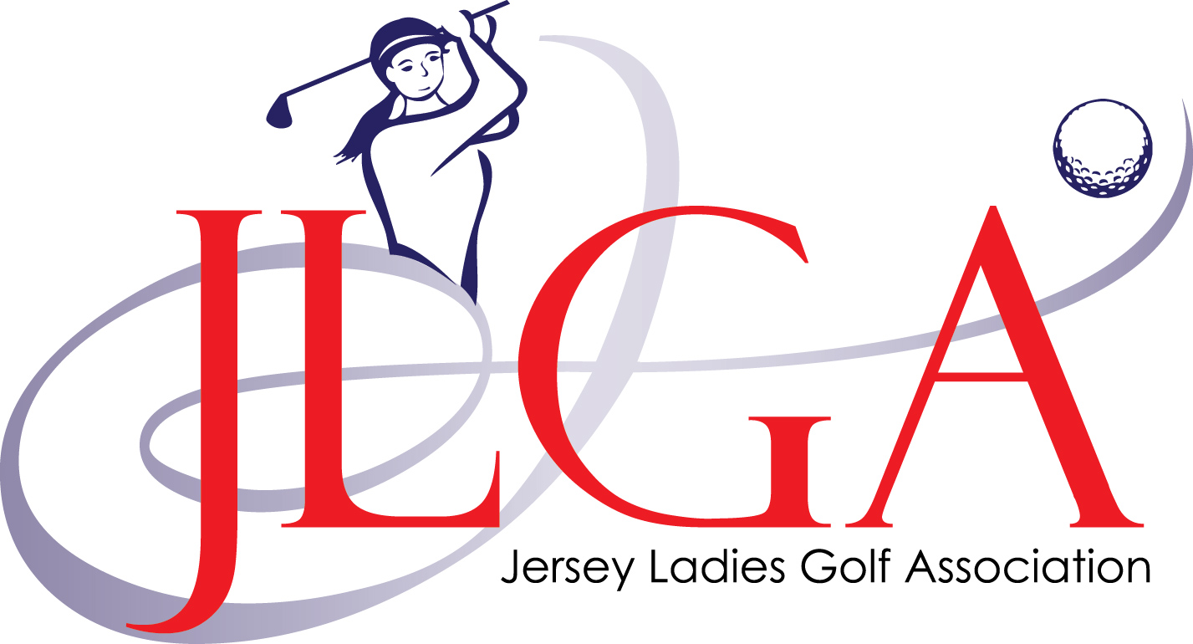

LADIES STROKEPLAY CHAMPIONSHIP
Sponsored by

Thursday 16th July 2020

La Moye Golf Club

The Ladies Strokeplay Championship is open to any members of any recognised LGU Club, fulfilling any one of the following conditions:

Qualification: 1. A competitor must be born in Jersey.
or
2. They must have resided in Jersey one year immediately preceding the Championship.
3. Any entrant who previously qualified by residence and returns to reside in Jersey shall not
be required to re-qualify.

Format: 36 Hole Strokeplay. (Gross scores)
DIV ONE UP TO 9.4 HANDICAP
DIV TWO 9.5 TO 18.4 HANDICAP

18 holes morning and afternoon
The winner will be the player with the lowest gross score after two rounds regardless of Division.
In the event of a tie for first place – there will be a sudden death play-off.
Both rounds are qualifying for handicap purposes.
The Sponsors and the JLGA invite all players for a light supper at the presentation.

Handicap: A competitor in the Championship must have an exact CONGU handicap of 18.4 or less

All entrants must be available to play in each round. Caddies are optional. Buggies will not be permitted during this competition. Distance Measuring Devices will be allowed. Players will be started in handicap order, commencing with the lowest out first.
The Entry fee is £20.00, please make cheques payable to ‘JLGA’ and send with this entry form to:
Annette Ramage. 73, de Bathe Place, Langtry Gardens, St Saviours, JE2 7AG

CLOSING DATE: Midnight Friday 10th July 2020

Cut>>>>>>>>>>>>>>>>>>>>>>>>>>>>>>>>>>>>>>>>>>>>>>>>>>>>>>>>>>>>>>>>>>>>>>>>>>>>>>>>>>>>>>>>>>>>>

ENTRY FORM
LADIES STROKEPLAY CHAMPIONSHIP 2020

NAME_______________________________________ (please print) TEL _______________________________

CLUB_________________________________________________ EXACT HANDICAP___________________

EMAIL ADDRESS _______________________________________ CDH NUMBER_______________________

Entry fee: £20 (no refunds will be given)

The information you provide will be used by and processed for the sole purpose of the Jersey Ladies Golf Association only. To ensure confidentiality and privacy, all processing will be compliant with the requirements of The Data Protection (Jersey) Law 2018.

