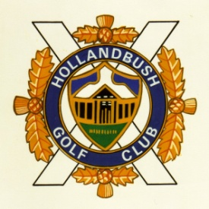

Hollandbush Golf Club

ACRETOPHEAD, LESMAHAGOW, ML11 0JS
Telephone 01555 893484

e-mail: - mail@hollandbushgolfclub.co.uk

Membership Form

(Club membership is available with no waiting list)

Full name (please PRINT) Surname ______________________________

Forename(s) ______________________________

Date of Birth ____________ Address ______________________________

___________________________________________ Post Code _____________
Telephone _________________________Mobile No _______________________

Email address (PRINT) ______________________________________________________

Type of membership applied for …………………………………………………………

CDH number …………………………………………………………………………………………………

Membership and Handicap at previous clubs (if applicable):

Handicap ___________ at ____________________ Golf Club. Date

NB: Failure to disclose information regarding all previous handicaps
will result in suspension and possible expulsion from Hollandbush GC

Where possible, a handicap certificate from your previous club should be attached to this form

If elected, I agree to abide by the Rules & Byelaws of Hollandbush Golf Club

Signature ________________________________ Date ________________________

