Hole | Team | Team
1st | Linda Olbison & Kathy Lawerence  20 (18) & 22 (20) | Stacey Sarre & Jacquie Callaghan  25 (23) & 28 (25)
1st | Jane Bailey & Melina Syred  19 (17) & 32 (29) | Irene Egglishaw & Carole Garwood  25(23) & 31 (28)
1st | Margaret Vautier & Betty le Luan  35 (32) & 29 (26) | Norah Quereé & Carole Upton  32(29) & 27(24) | Norah Quereé & Carole Upton  32 (29) & 27 (24)
2nd | Ann Pasturel & Shan Christmas  29 (26) & 27 (24) | Jackie Morris & Zahida Yousaf  26 (23) & 24 (22)
2nd | Catherine Goddard & Patricia Fior  22 (20) & 19 (17) | Anita Whitnell & Pat Pagett  21 (19) & 36 (32)
3rd | Mary Audrain & Sue Garry  33 (30) & 33 (30) | Marker
3rd | Sarah Jane Mundy & Anita Illien  20 (18) & 34 (31) | Jane Gregory & Michelle Leerson  29 (26) & 31 (28)
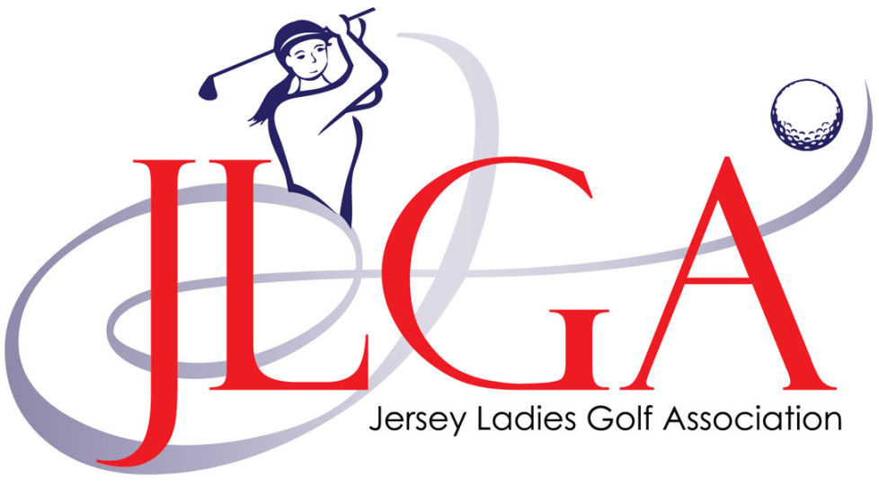

Bronze Better Ball Stableford
Thursday 5th September 2019
At St Clements Golf Club
1pm shotgun start

EACH PLAYER PLAYS OWN BALL OFF HANDICAP ALLOWANCE (90%) IN RED
TAKE BEST STABLEFORD RESULT FROM EACH PAIR AND RECORD ON CARD ALONG WITH GROSS SCORE
WHEN OUT OF SHOTS PLEASE PICK UP
EACH 9 SHOULD TAKE NO MORE THAN 2 HOURS TO COMPLETE
LONGEST DRIVE ON 10th
NEAREST THE PIN ON 5th & 14th

Presentation and a drink in the clubhouse at the conclusion of the competition.

