GENTS SECTION AGM and PRIZE GIVING - 10TH January 2019

The meeting opened at 2 p.m. with Tony J.A. Laing (Gents Captain) in the chair

Apologies received: Alan Bolton, Bill Morrison, Lee Buck, Bob Gill

Approval of minutes 2017: approved by D. Harknes and seconded by S. Dyker

Captains Report (T.J.A.Laing)
1. Gents committee – We have again managed the gents section activities with a small group of volunteers (Tony Laing, Colin Leach Dave Gordon, Dave Storm, Bill Murphy, & Gordon Spence) to organise and run (with volunteer help) a wide range of competitions through the year.
This year we have had some of the largest number of participants in club competitions for some years.
Gents New Letter (Spring, Summer and Autumn) has proved to be a great success (positive feedback) providing a key summary of activities communicating directly to the Gents Section.
2.Course condition –
This time last year ‘an ice rink’ to the driest summer for decades; ‘what a challenge’
A big thanks to Mark and his green staff for progressing the quality of the course over the season. We have received great feedback from visitors and members; contributing to the high entry levels in competitions, both club and opens.
This is reflected in the clubs success; reputation, new members, with the bottom line being finance.
3. Fun events and opens – we have had another good year with our open competitions this season, with most events being full.
4. We ran a number of successful raffles on a range of Open competitions with prizes typically being a fourball and putter/wedge (thanks to Ross for providing these at cost price) to raise additional money for the course improvement fund
5. Armed Forces Day - £750 was raised; ‘squares’ draw at the Gents & Seniors Opens
6. We saw a new course record of 62 by Adam Fisher during the Gents Open
7.On a serious note the club lost a number of members: Dennis Anderson, Jim McBeath, Stan Kerr, Peter Robertson, Andy Howe and Arthur Legg (member of the Greens Staff)
8 . Pennant and Deeside League PGC showed a good performance; highlighting the range and variety of players in the club – more about that later.
- Thanks to Nick McDonald for organising the Deeside League
- Thanks to Ross for organising the Pennant League – won scratch knock-out
9. Junior Pennant were well represented with some great scoring by the Juniors
10. Heath & Safety, Speed of play and Etiquette
11. Clubhouse – Thanks to Audrey and the team
12. Professional – Thanks to Ross and his supporting staff
13. Marketing – Thanks to Kirsty for leading Marketing

2017 Questions Raised
- Combating balls to left of 18th hole – plant more trees (T.Robertson), move bunker to LHS fairway/to play more to the right - CLOSED
- Water logging 13th tee area (G.Stalker) – repair to be completed during winter programme - CLOSED
- Put a webcam in place to capture weather conditions at club - OPEN
- Winter greens – loose caps on holes, can these simply be removed as they are loose on several holes and impact putting (T.Robertson) - CLOSED
- Winter greens – can these be prepared earlier so that they can be used when summer greens flooded, which in turn closes the course (A. Bolton) - CLOSED
- Winter greens can we get the distance from the centre of the winter greens to the summer greens measured and a table published online to help winter golf play please?(C.Leach) - CLOSED
- 14th green extension – was extended for more pin positions, but front not used (J.Kennedy). Front surface was cut down to clarify if it could be used as putting surface and given that this has passed that test, work will be performed in winter to improve the overall surface - CLOSED
- Clubhouse cost of drink was raised as an issue by several members who thought prices were too high for both alcoholic and non-alcoholic drinks. Could we expand non-alcoholic options for beer? - OPEN
- Level all tees – these are poor for both visitors and members on many holes (T.Robertson) - CLOSED
- re there any lower cost options for sport on TV (football/golf) that we could use to attract more people in. Pay for events and highlight them to members and link then to say a lunch or evening meal as a package? - OPEN
- Put an event on with the AGM/Prizegiving to attract more people and open a coffee shop as little by way of options in Culter, people will drive to this! (T.Robertson) - OPEN
- Improve walking access to the club and keep access road in good condition (fill the potholes) G.Stalker. - OPEN
- Could the winter tee boxes be salted to prevent them from being so slippery? Some feedback suggested that salt may have a detrimental impact on the mats; need Course Manager to confirm best way forward to reduce slippery surfaces – CLOSED
Note: majority of items are closed, with 4 items considered open – these will be addressed at the Club AGM (Wednesday the 27th of February)

Finance Report (D.Storm)
- No change to the existing process to charge an Entry Fee for competitions with prizes set at a fixed rates. There are 10 prizes for each Medal (£175) and 9 for each Stableford (£150). The same process and entry fee/prize structure will continue for 2019
- 60 events were scheduled in 2018. We hope that the Medal and Stableford mix this year was balanced and met the preference of the majority of members
- 7 competitions were rained off or cancelled after play had started. This is exactly the same number as in 2017 and in line with prior years
- Average income per competition was £62.60 over the season. High average August (£95), low average Sept/October (£12), some were loss making. This income is used to fund recurring spend commitments of the Gent’s section
- The Committee also funds discretionary items deemed to be of benefit to the Gents Section and Club membership in general. We would welcome suggestions at any point on possible ‘common good’ spend items
- Note that expenditure to cover inter club, Pennant League, Deeside League etc. do not come from Gent’s income. This is funded via the Annual Club Budget. Likewise, income from annual Open events are to the Club funds, not Gent’s Section.
- Gents section wish to donate money to support the Junior Section, to promote the juniors; discussions have been around tops etc.

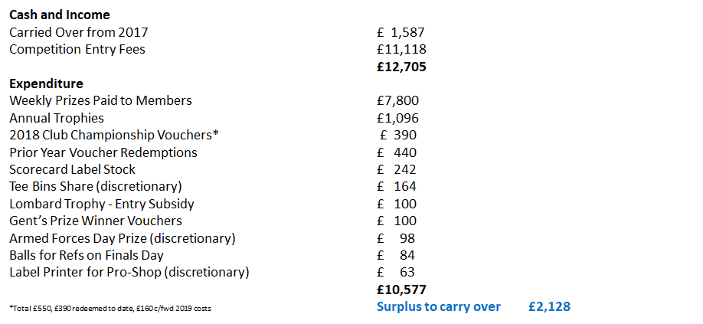

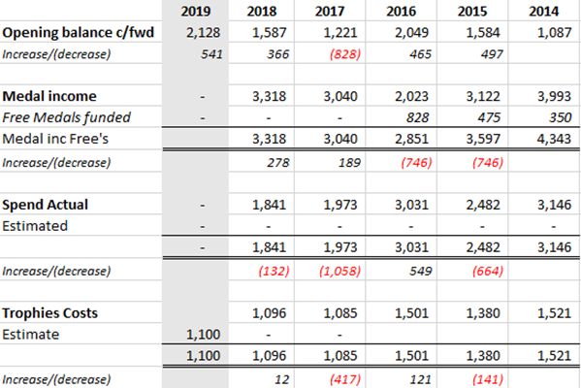

Note: The surplus is ring-fenced towards the following:
- 2 off new computers £250, with the club and the Ladies sections supporting the balance
- Junior section supporting the ‘existing junior’ members, discussions around Pennant Tops and potentially an away day.

Course Update (C.Leach)

New rules: biggest change since in the last 50 years
- New rules aimed to speed up play and offer clarity
- Communications will be issued, via Ross and Gordon Telfor
- Typical links https://img.bluegolf.org/files/pgagbi/National_Tournaments/PGA_Rules_Fact_Sheet.pdf

The weather at the end of 2017 and start of 2018 saw a lengthy cold snap that restricted the amount of work that could be done to advance the winter work programme. We then went on to have one of the hottest spells that ‘baked’ a number of the fairways and we had to restrict watering to the greens as the water level of the river Dee was getting so low. We are still seeing the results of the summer heat with areas of fairway bare of grass, however this has happened before and Mark is confident that it will recover quite quickly once the growing season starts. This will be monitored closely and where necessary grass seed will be spread as required.

The weather for the 2018 winter work programme has been much warmer and very good progress has been made with valuable help from Nicol of Skene, which is much appreciated. The works completed so far includes:- Path down to the 2nd Tee tarmac laid and stone dyke built, a number of other pathways have been scraped and tarmac laid to improve the look a wear, the wood wall at the 6th Tee has been removed and area landscaped, the sleepers removed from the 6th have been used o make a viewing platform at the 17th tee, patching of bare areas and paths laid at various locations including the 8th, 9th & 15th, 14th tee has been stripped, levelled, sprinklers moved and re-turfed, 14th green has been raised on the left side to increase pin locations and improve the putting surface, the right hand bunker at the 17th green has been filled in.

The winter work programme is in full swing with a lot still to do by Mark and the team to get everything ready for the new season that is fast approaching. All greens have been Verti drained, Tined, rolled, cut and used when conditions allow during the winter.

A welcome note from Mark is that Jumbo coring of the greens will not be done in the spring and only carried out in October. This is because the programme to reduce thatch has been very successful over the last 3 years.

Finally, a big thankyou to Mark and all the Green staff for all the hard work that they continue to put in to make our golf course what it is with many visitors complementing on its condition and friendly welcome.

M&H (Gordon Spence – Tony stood in)
The Junior section has been addressed in the Gents section, throughout the year to support Gordon, and the Gents Section gave Gordon representation in the Management Team.
Junior Pennant
- The pool was won by Royal Aberdeen, however PGC won their match 4.5 to 0.5
- There are new rules for the pennant teams;
  - 6 person teams (girls or boys)
  - Played in May & June instead of April and May – avoiding exams
NB: these means that PGC shall be able to enter a Pennant Team.
The Junior Club Championship knockout rounds were completed. The results were:
- Junior Scratch Champion Cameron Fraser beat Charlie McDonald
- Junior Handicap Champion Jeremy Graham beat Sam Allan
- Most Improved Player Jeremy Graham

Junior Development - plans
This is an area of concern for some years as this requires long-term plans, which does require engagement from the golf professionals. The concerns around the Junior Section fall into 2 areas, these requires a considerable amount of focus:
- Transition from the Coaching Section
- Sustaining the existing juniors and building new juniors.
NB: these require to be equally address as a matter of priority.

There has been additional professional support being discussed and the intention is for programme to be developed.

NB: Today and moving forward Juniors require to address both boy’s and girl’s; Tony and Liz Clark have been engaged with input on the way forward.

Coaching Session (Trevor Gross)
Trevor has been leading the Coaching Section for 12 years and we thanked his effort and commitment. The following offer a summary;
- Coaching programme has over 60 children taking part and a healthy waiting list
- New format lessons introduced with more emphasis on games to embed lessons
- Family fun golf events introduced and enthusiastically taken up by parents/kids
- Family open events run as part of our membership drive, successful in bringing in new members
- Fantastic end of season flag competition and family BBQ for coaching kids/parents
- Good progress towards handicap made by several children, but most notably Lottie Rhodes and Owen Boylan
- After 12 years and some 600+ children later I will be handing over the running of the children’s coaching to Jo McCloskey
- Huge thanks to all of the coaches that took part; always more needed

Seniors (D. Gordon)
The Seniors section have had another active year, with great success, highlighted below;

- The PEGGS Senior Gents play Monday morning games through the Spring and Summer this season has generally been played in the good weather which has been welcomed by golfers throughout the country. We are all however preparing for the coming Autumn and Winter weather. During the winter season we still meet on a Monday morning with the weekly draw for tee times allocating a number of games with an early start from the 7th Tee. The course in the winter is shorter and with our local handicap arrangements for the Monday games it makes it easier to reduce your handicap and adjustments are made to keep everyone in with a chance of winning!
- The Senior Gents, not restricted to PEGGS Members, have also played the usual “Friendlies” home and away matches against 8 other local clubs - Aboyne, Banchory, Craibstone, Deeside, Kemnay, Portlethen, Stonehaven and Westhill. This year in the 16 matches Peterculter had 6 wins, 2 draws and lost in 8 but all enjoyed the bacon roll and tea/coffee before and a 2-course meal with tea/coffee after playing.
- The Senior Friendlies were organised this year by Neil Craig, David Johnstone and Athol Garden; thanks for all their effort, making these events a great success
- In addition to the Monday matches Senior Gents have played in Central Aberdeenshire District Seniors (CADS) league open to all Senior Members involving 14 clubs with each club hosting one CADS event per season
- This Season we finished a very credible second with 116 points only 2 points behind the winners Alford. Congratulations are due to all those who have taken part!
- The CADS Teams this year have been organised by Fred Talbot, Geoff McQuillan and Archie McCallum; Thanks for all their effort, making these events a great success

M&H (B.Murphy)
2018 season was an exceptional season, both with participants in Club and Open competitions. This can be accounted for a number of factors, from the high level of members interested in playing golf at all levels. The following offers key highlights;
- Club competitions well supported – Wednesday medals often > 130 members and more popular than weekends
- Medals vs Stableford Competitions: 2019 - 50/50 balance
- Greensomes & Fourball Competition: omitted in 2018 after low turnout historically – so not included in diary for 2019
- New stroke index implemented in 2018; generally accepted
- Winter League - entrants are down on 2017 (8 pairs on Saturdays and 6 on Sundays). The league was advertised well in advance of the season ending, in line with 2016 to try and encourage greater uptake. Getting to point where the committee has to decide whether to continue with current format. One possibility is to make do with the sweep run through the pro shop with a £1 entry fee. Suggestions of alternative formats are welcome.
- A huge thanks to George McMullan for organising and running the knockout competitions, excellent work yet again from George but he has confirmed his intention to stand down for next year so another volunteer would be welcome. The intention for 2019 is to use the ClubV1 system to enter and run the competition and we are looking at how this might work – traditional list will be put up in the locker room as usual.
- Computer Terminal for Shop and Clubhouse – the Gents Section has ring-fenced monies towards the 2off computers.
8. Phil Robb and Robert Wilson will represent the club in the 2019 Evening Express champion of champions competition.

Election of Office Bearers (T.J.A. Laing)

The success of the Gents Section is down to the volunteers and the following roles are available to fill;
- Vice Captain (Colin is moving from the club)
- Treasurer (Dave has performed this role for 3 years and wishes to hand the role on)
- M & H (Bill has performed this role for 2 very busy years and wishes to hand the lead of this role on). Bill Murphy is standing down as M & H Convener, which will leave a huge gap. Bill wish to support the Gents Committee moving forward and be an advisor for M & H activities.

There was an appeal for new volunteer as this is key for the success of the Gents Section and for the competitions to be successful and sustainable more volunteers are required. This appeal is critical.
- D. Harkness offered to assist as Gents Greens Representative
The Gents Section have developed a break down of activities for each function to enable visibility for all that are interested in supporting the section. This breakdown provides a structure where activities are broken into logical groupings, with estimates of time. The aim is to make it easier for more people to be engaged.

Questions Raised

Questions raised in 2017 AGM and Prizegiving

A review of 2017 questions was summarised, with the majority of them being closed, with the remaining open questions fall into the scope of the Club Management and will be responded to during the club AGM.

Questions raised 2018 AGM and Prize Giving
- Burnt fairways and seeding of them now. (see course update)
- G. Stalker proposed a winter Eclectic. Who or how to run it and would look into how Northern did it.
- M&H and who is prepared to help out the Gents Section and do this.
- Club comp H/cap 54 and opens max 28.
- Comment was made on the fact that the AGM was not closed door with other members coming and going disrupting proceedings.
The gents annual prize giving successfully followed the AGM.
Congratulations to all winners and we wish them all the best for 2019.

Closure

Club AGM on the 27th of February, please attend as it is everyone’s responsibility to contribute to the Club’s direction.

Tony wish all a thank you for everyone’s support though out 2018 and wished them all the best for 2019

Jim Cook on behalf of the club members attended, took the opportunity to thank the Gents Section in all their hard work throughout the year.

