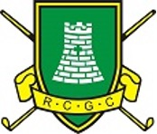

ROWLANDS CASTLE GOLF CLUB
MIXED OPEN
SUNDAY MAY 26th 2024
18 Hole 4BBB Stableford (85% handicap allowance)
Handicap Limit 21.1 (men) 31.4 (ladies)
Entrance fee: £90 per couple
To include tea/coffee and biscuits on arrival,
2 course meal afterwards.
Prizes will be sent.

Lady Captain’s Charity Raffle in aid of The Rowans Hospice and St Wilfred’s Hospice.

Tee times start at 8.30am
CLOSING DATE: 10TH MAY 2024
No refunds after closing date but substitutes will be allowed
To enter click here
The contact for this competition is Debbie Tapply
ladies@rowlandscastlegc.co.uk
Please email housemanager@rowlandscastlegc.co.uk
if there are any dietary requirements

