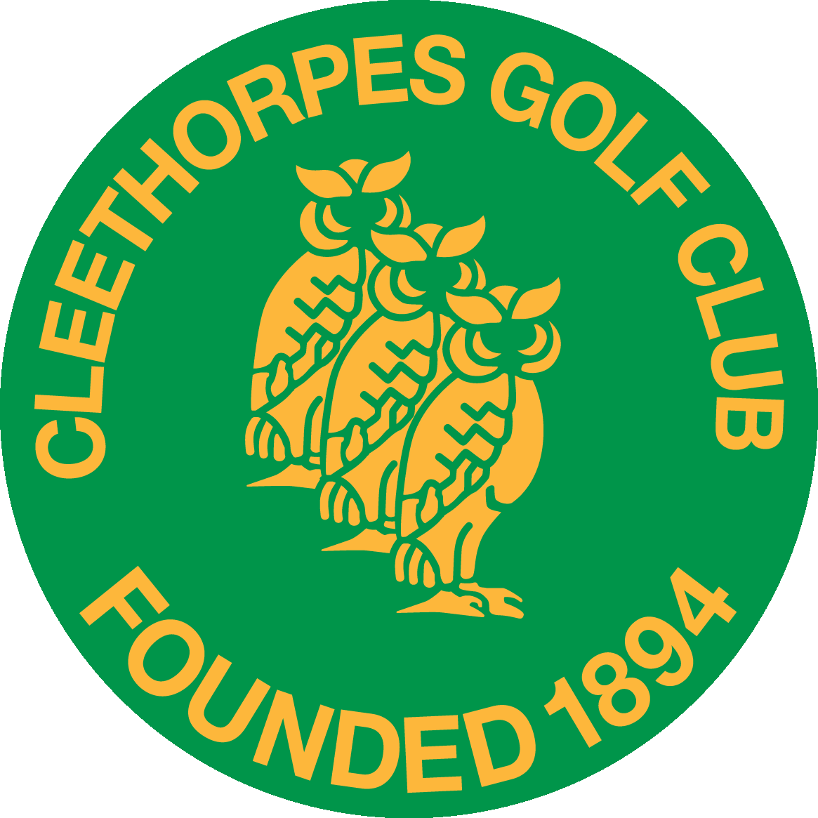
CLEETHORPES GOLF CLUB
SENIOR MEN’S OPEN
BETTERBALL (PAIRS) STABLEFORD

on
THURSDAY 9th SEPTEMBER 2021

ENTRY FEE £44 per pair (includes a one course meal & tea/coffee)
(£5 reduction for each Cleethorpes Golf Club member)

HANDICAP LIMIT:- 28 HANDICAP ALLOWANCE:- 90%
Includes Nearest the Pin & Halfway House

Open to Gentlemen over the age of 55 (age on date of competition)

Betterball Pair | Name | Home Club | Age | Handicap

Player 1

Player 2
Betterball Pair | Name | Home Club | Age | Handicap

Player 1

Player 2
Approximate preferred start: Early / Mid / Late

Contact Name ……………………….………………………… Email: …………………..…………………………
Address ……………………………………………………………………………………………………….……….……..
……………….…………………………..……… Telephone No ………………………………..…………………
Handicap Certificates will be required Entry Fee £ ………..
Please indicate your meal preferences below:
Fish & chips ......... Steak & ale pie, new potatoes, vegetables …..….

N.B. Desserts will be available to order and paid for on the day.
Entries close 30th August 2021
Your tee time will be confirmed by email or telephone. Please send your entry form and cheque to:
The Manager, Cleethorpes Golf Club, Kings Road, Cleethorpes, N. E. Lincolnshire, DN35 0PN.
Tel: 01472 816110 (Option 3) email: secretary@cleethorpesgolfclub.co.uk www.cleethorpegolfclub.co.uk

