Maximum 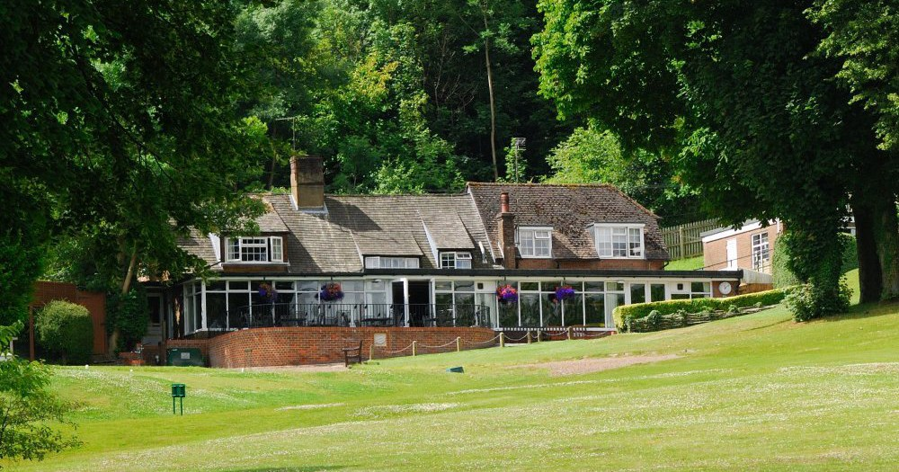
WHITELEAF GOLF CLUB
COME AND ENJOY OUR HOSPITALITY AND PICTURESQUE COURSE

LADIES COFFEE MORNING AND GOLF
TEAMS OF THREE
THURSDAY 19 MAY 2022
Maximum Handicap Index 36
£19.95 per person to include Tea/Coffee
and Danish Pastry on arrival and 18 holes of Golf

Should you wish to stay for lunch afterwards a varied bar menu will be available.
Please complete and return the entry form below

1st Name.......................................... Club..........................................................

Tel ................................................. Email........................................................

2nd Name......................................... Club..........................................................

3rd Name.......................................... Club..........................................................

Please return to Sue Wakefield, Admin Secretary
Whiteleaf Golf Club Ladies Section,
Upper Icknield Way, Whiteleaf, Princes Risborough, Bucks HP27 0LY
Cheques should be made payable to: WGC Ladies Section

You will be notified of your tee time by email

WHITELEAF GOLF CLUB
COME AND ENJOY OUR HOSPITALITY AND PICTURESQUE COURSE

LADIES COFFEE MORNING AND GOLF
TEAMS OF THREE
THURSDAY 1 SEPTEMBER 2022
Maximum Handicap Index 36
£19.95 per person to include Tea/Coffee
and Danish Pastry on arrival and 18 holes of Golf

Should you wish to stay for lunch afterwards a varied bar menu will be available.
Please complete and return the entry form below

1st Name.......................................... Club..........................................................

Tel ................................................. Email........................................................

2nd Name......................................... Club..........................................................

3rd Name.......................................... Club..........................................................

Please return to Sue Wakefield, Admin Secretary
Whiteleaf Golf Club Ladies Section,
Upper Icknield Way, Whiteleaf, Princes Risborough, Bucks HP27 0LY
Cheques should be made payable to: WGC Ladies Section

You will be notified of your tee time by email

