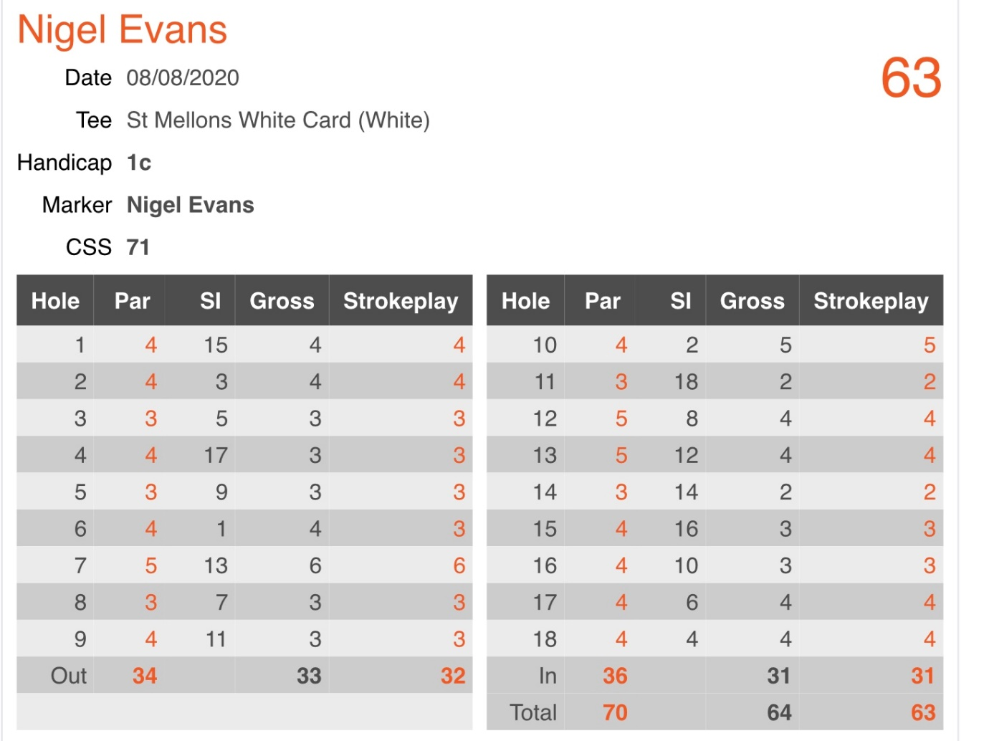

Congratulations Nigel Evans on a new course record.

