Seniors Mixed Open
Tuesday 7th July 2020
Handicap Limit:
Men 28 Ladies 36
Age Limit: Gents 55yrs+ Ladies 50yrs
Greensome Stableford, played off half-combined full handicap Cost: £30 per Couple, including 2’s

Player 1 _____________________________________ Hcp___
Club ________________________________________
Player 2 _____________________________________ Hcp___
Club ________________________________________
Player 3 _____________________________________ Hcp___
Club ________________________________________
Player 4 _____________________________________ Hcp___
Club ________________________________________
Preferred Tee Time: _________ Tel No: _______________________
Email address for confirmation: ________________________________
Email: secretary@withingtongolfclub.co.uk
Or send to:
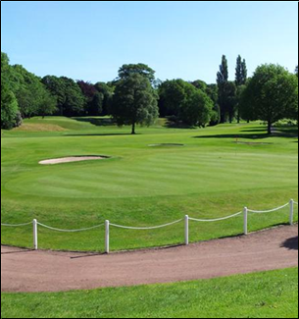
Withington Golf Club
243 Palatine Road
West Didsbury
Manchester
M20 2UE

Tel: 0161 445 9544 Ext. 5

