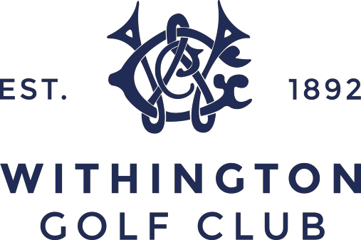

SUBSCRIPTION LEVELS FOR 2021/22

7 Day £968
6 Day £774
5 Day Frozen £690
Young Player 35 to 39 £871
Young Player 31 to 34 £774
Young Player 28 to 30 £726
Young Player 25 to 27 £484
Young Player 21 to 24 £290
Youth Player 18 - 20 £194
Student £323
Affiliate £270

Junior 16 & 17 £80
Junior - 13 to 15 £50
Junior – under 12 £35
Social £42

Playmore Golf – Flexible Membership
A points based membership scheme available at selected golf clubs in the UK.
If our traditional membership package does not suit your lifestyle,
you can still enjoy all the benefits of a Club Membership for just £350.00
For more information & join online go to PlayMore Golf.

Please Note:

All Gentlemen categories are subject to £15.25
England Golf/Cheshire Union Fees & £3.50 insurance.

All Ladies categories are subject to £14.50 England Golf/LGU Fees, £3.50 insurance and £45.00 Competition Levy for all Ladies with an official handicap.

All members will be charged a 3% bar pre-payment.

243 Palatine Road • West Didsbury ⁬• Manchester • M20 2UE Tel: 0161 445 9544 • Professional 0161 445 9944 x 2 www.withingtongolfclub.co.uk • Email: secretary@withingtongolfclub.co.uk Company Reg No 166676 VAT Reg No 245 4750 02

