KINROSS GOLF CLUB, LTD

Registered in Scotland No. 1750 R (S)
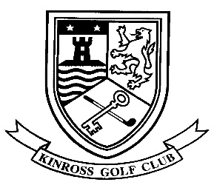

Golf Clubhouse, Beeches Park, Kinross KY13 8EU
Tel:01577 862237 Fax: 01577 862309
E-mail: office@kinrossgolfclub.co.uk Or manager@kinrossgolfclub.co.uk

I hereby apply for Membership of KINROSS GOLF CLUB, subject to the terms of the Constitution of the Club.
PLEASE PRINT IN BLOCK CAPITALS
Surname |  | First Names
Address |  | Phone – Home
 |  | Mobile
 |  | Work
Postcode |  | Date of Birth
E-mail address
Signature

Current Handicap :
Details of Previous Club(s) where you have been a Member:

How did you hear about us?
Website |  | Facebook/Twitter |  | Friend/Member
Local Press |  | Pro Shop |  | Other

Proposer:
Name:
Address:
Signature:

Seconder:
Name:
Address:
Signature:

If you require any further information please call Susan Quinn, Club Administrator or Iain Wallace, Club Manager on 01577 862237

Data Protection – We will not pass your personal information on to any 3rd Party.
General Data Protection Regulation – a copy of our Policy is available on request or via the website.

Membership Terms & Conditions

By returning this Form complete with your Deposit you are agreeing to have your name and address displayed on the Club Notice Board for a minimum of seven days.

The Application will then be presented to Committee for approval.

During the above process prospective Members will be eligible to play non-competitive golf as a temporary member.

Given the Application is acceptable the offer of Membership will be open for fourteen days after which the offer shall be withdrawn.

The deposit already paid shall be deducted from the appropriate due subscription.

Once Membership has been established both member and Club are bound by the Constitution of Kinross Golf Club.

Should for any reason the Application be refused, playing rights will be revoked and the Deposit returned in full.

A £50.00 deposit is required with your Application

OFFICE USE ONLY:

Date Application Received:
Date Application Approved:

