Golf Etiquette; the basics
Etiquette is a word that's often heard in relation to golf, more so than with any other sport. But it's not just about manners.
The guidelines for good golf etiquette are what they are for several very important reasons: many of them relate to the safety of golfers, many relate to pace of play (which helps keep the game enjoyable), and other rules of golf etiquette relate to maintaining the quality of the golf course.
If you are new to the game, or just need to brush up on your golf etiquette, here are some basic rules of the road that will help keep the game enjoyable for you and those around you.
Keep it safe
Do not swing your club until you know that others in your group are at a safe distance. Likewise, keep your distance when others are swinging. Be aware to steer clear of trouble.
When practicing your swing, never swing in the direction of another player. There may be pebbles or twigs or other matter in the grass that could fly up and strike a playing partner.
Do not hit the ball until you are certain that the group ahead of you is out of range.
If your ball appears headed toward another player or another group, give them a warning by yelling out, "Fore!" (an internationally recognised alert)
Never throw clubs in anger. In addition to being rude and childish, it could also be dangerous.

Maintain a Good Pace
Keep the round moving by being prepared to hit your shot when it is your turn. You probably don't like waiting on other groups - don't make other groups wait on you.
The player with the best score from the previous hole hits first in a group. However, this rule can now be ignored in favour of "ready play" - players hit as they are ready. All players should agree to "ready play" before it is put into effect.
Do not spend too much time looking for a lost ball, particularly if there is a group behind you ready to play. If you insist on taking the full three minutes allotted in the rule book to look for lost balls, golf etiquette says wave up the group behind to allow them to play through.
Always try to keep pace with the group ahead of you. If space opens in front of you, allow a faster group to play through.
Always leave the putting green as soon as your group has finished putting.
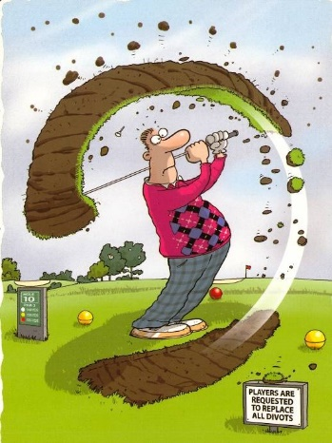
Be Kind to the Course
Trollies should be kept off greens, green fringes, tees, areas marked GUR (ground under repair) and areas marked by greenkeepers. The wheels on trollies can damage these sensitive areas
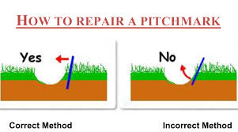
Repair your divots in the fairway and repair your ball marks on the green.

Always rake sand bunkers after hitting to erase your footprints and damage to the area where your ball was.
Avoid taking a divot on a practice swing.
General Golf Etiquette Hints
Never talk during another player's swing, or use a mobile phone on the course unless in an emergency.
Do not yell out following a shot (unless you are yelling "fore"). Even if boisterous behaviour doesn't bother your playing partners, there are other people on the course who may be within earshot.
Be aware of your shadow on the putting green. Don't stand in a place that causes your shadow to be cast across another player or that player's putting line.
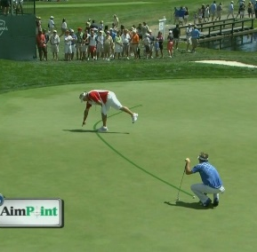
Never walk through a playing partner's putting line. Your footprints might alter the path of a partner's putt. Step over the putting line, or walk around (behind) the partner's ball.
When a playing partner is swinging or putting, try to stand out of his or her line of vision, and remain quiet during the other golfer's swing.
These are the basics of etiquette on the golf course, there is a wealth of information on the internet along with a variety of videos which are worth exploring.

