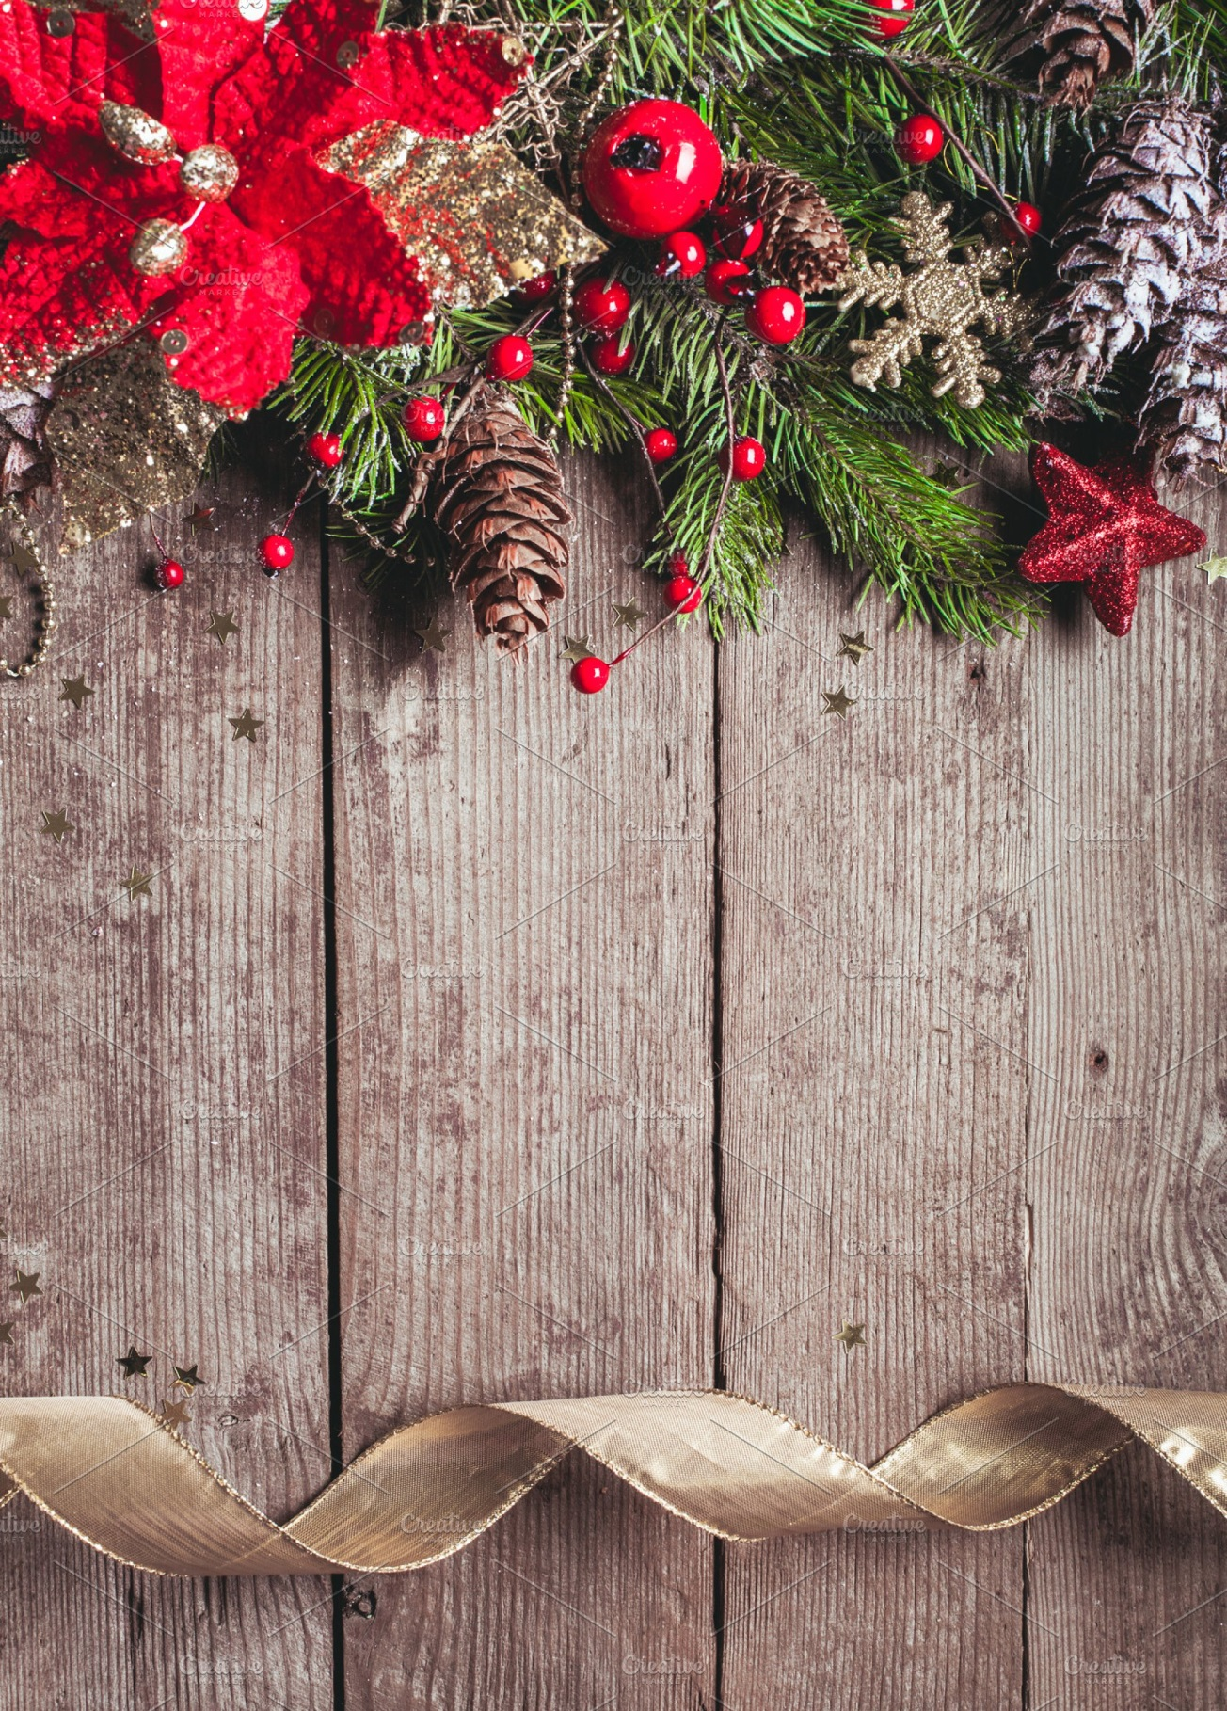
0

Christmas 2019 at Balbirnie Park Golf Club

Christmas Lunches & Dinners
Served from Friday 6th December – 20th December

Christmas Day Lunches 25th December 12 – 4pm

Hogmanay Dance 31st December with Hot Buffet 7pm – 1am

Season’s Greetings from us all at Balbirnie

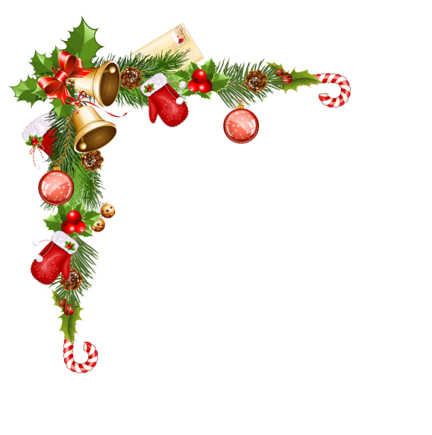
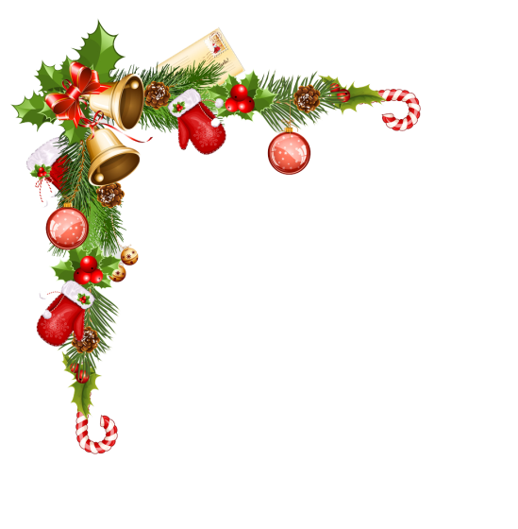
Christmas Fayre Lunch & Dinner
Homemade Soup with warm Roll
Sweet Chilli and Coriander Prawns
Brussels Pate with Chutney Oatcakes
~~~
Traditional Roast Turkey
Beef Bourgignon
Fillet of Salmon with Creamy Lemon Sauce
Mushroom, Brie & Cranberry Wellington
All served with Roast & Boiled potatoes and seasonal vegetables
~~~
Christmas pudding with Brandy Sauce
Chocolate Yule Log with Ice-Cream
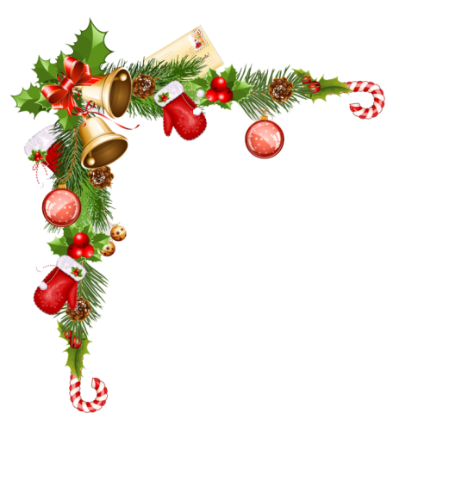
Spiced Berry Sundae
~~~
Tea or coffee with homemade Tablet
2 Courses £19.50 3 Courses £22.50

Christmas Day 2019

Hors D’oeuvres
Serve yourself and choose from our
selection on the buffet table
~~~
Carrot & Coriander Soup
~~~
Traditional Roast Breast of Turkey
Sirloin Steak Bordelaise
Pan-seared Fillet of Salmon with Herb Crust
Individual Vegetarian Tartlet

All Served with Roast & Boiled potatoes and seasonal vegetables

~~~
Christmas Pudding with Brandy Sauce
Raspberry White Chocolate Roulade
Posh Sundae
Scottish Cheddar with Biscuits
~~~
Tea or Coffee with Homemade Tablet
£49.50

Hogmanay Hot Buffet

Chicken Curry
Steak Pie
Lasagne
Macaroni Cheese

All served with a choice of Rice, Chips, Salad Bowl or Peas

~~~

Dance the night away to “Little Big Sound”

£15.00 per person

£5.00 deposit required on booking non-returnable

