**Rabbits News**

**No. 1/249 January 2020**

**ENDURING DURO WINS GOLFER OF THE YEAR 2019**

**Consistent performance throughout the year saw Steve Duro come through another endurance test to take the Social Rabbits Golfer of the Year Trophy for the third consecutive year. Ian Chitty won the Eclectic with Sixty Two, without getting birdies on all the par threes – beating Steve Parkinson (who also had Sixty Two) by virtue of a higher total number of birdies. Ian’s tally of seven birdies won him the title of the “Bawtry Flyer”.**

**Steve Duro, Socials Supremo. Ian Chitty with the Electric Eclectic**



**RABBITS AGM**

**6th FEB. 7.30 pm**

**The AGM of the Rabbits Section will be held at the Clubhouse at 7.30pm on the Thursday 6th February. The usual business of electing the Captain, Officers and Committee will be carried out together with reports from the outgoing Captain, Secretary ,Treasurer and Competitions Secretary on how the section performed during 2019. Presentations will be made to the winners of the Buck Rabbit Trophy and the Eclectic Salver and the winner of “Lurker of the Year” will also be announced.**

**Following the re-introduction of Pie and Peas after the meeting last year, it will round off the evening in a convivial form again this year. Very good value for just £6.00.**

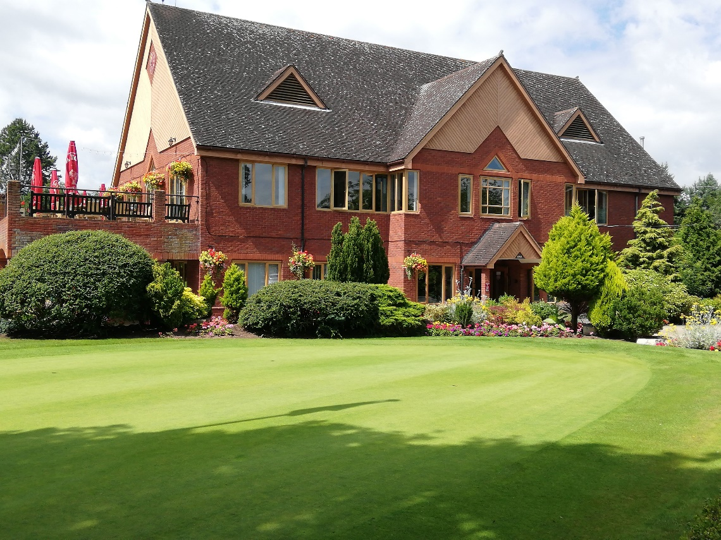**The Rabbits Section is by far the largest and most active section in the Club, so come along on the 7th February and join in its success. A “sign up sheet” is on the Rabbits Notice Board now.**