Committed to delivering a safe environment

www.safegolf.org
for golf

Is something worrying you?
Do you need someone to talk to? Speak to your club welfare officer
hgcwso@hotmail.com
07976759563
Daniel Claridge

Dedicated public servant, committed to safeguarding with extensive training in my current role as a wholetime Firefighter and experience of working with vulnerable Children under local authority care. I have a decorated and distinguished military career, having proudly served 25 years in Her Majesty's Royal Marines. Father to two children and husband to Em, with a huge passion for golf and the development of youth sports.
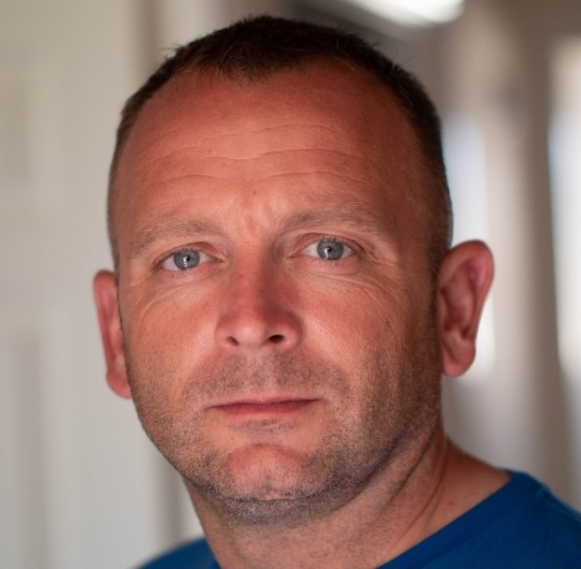

Alternatively, you can speak to someone at

ChildLine 0800 1111
NSPCC 0808 800 5000
England Golf 01526 351851

Club
WELFARE
officer

