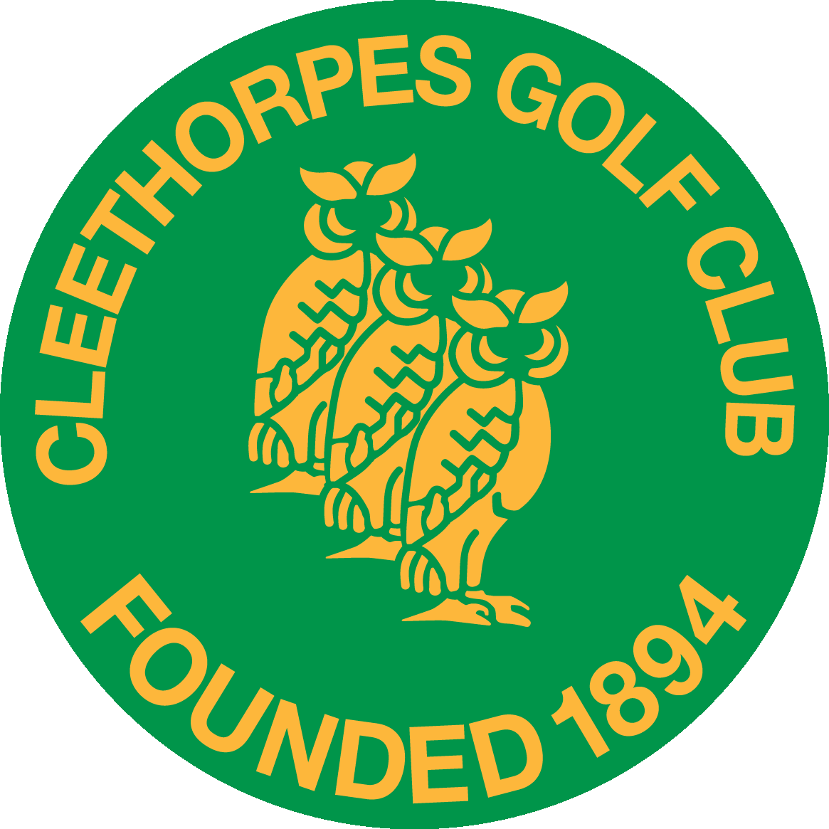

CLEETHORPES GOLF CLUB
MIXED OPEN AM/AM STABLEFORD
on
SUNDAY 12th SEPTEMBER 2021

TEAMS OF FOUR - ENTRY FEE £22 PER PERSON
including Fish & Chips or Steak Pie & a Halfway House
(£5 reduction for each Cleethorpes Golf Club member)
HANDICAP LIMIT: Men: 24 Ladies: 36
ONE LADY AND ONE GENTLEMAN TO SCORE ON EACH HOLE
HANDICAP ALLOWANCE: 90%
 | Name | Home Club | Handicap | Meal Choice
Mr |  |  |  | Fish/Steak pie
Miss/Mrs |  |  |  | Fish/Steak pie
Mr |  |  |  | Fish/Steak pie
Miss/Mrs |  |  |  | Fish/Steak pie

Approximate preferred start: Early / Mid / Late

Contact Name ……………………….…………….………………………… Email: …………………..…………………………
Address ………………………………………………………….………………………………………………………….……….……..
……………….…………………………………….…..……… Telephone No ………………………………..…………………

Entry Fee Total £ …………….
Entries close 30th August 2021

Your tee time will be confirmed by email or telephone.
Please send your entry form and cheque to:
The Manager, Cleethorpes Golf Club, Kings Road, Cleethorpes, N. E. Lincolnshire, DN35 0PN
Tel. 01472 816110 (Option 3) e-mail: secretary@cleethorpesgolfclub.co.uk
www.cleethorpesgolfclub.co.uk

