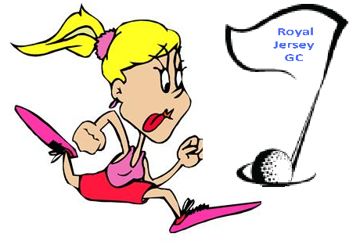
Entry Form
Junior Girls
The Race to Royal Jersey 2018
For girls with OR without handicaps

YOUR NAME_______________________

YOUR CONTACT DETAILS – Tel. no. _____________ e mail ______________

Where do you have lessons? _____________________

If you are a member of a club, which club? ____________________

Do you have an official handicap YES/NO – if you do what is it? ______

Tick the box for each competition you THINK you may be able to enter – cost will be £6, to be paid on the day which will cover supper.

Wheatlands – Monday 23rd July – 2.30pm

St Clements – Monday 30th July – 2.30

La Moye - Monday 6th August 3pm

Les Mielles - Monday 13th August – From 2.30

Royal Jersey – Thursday 23rd August 1pm

(to coincide with the Carol Le Feuvre Cup)

Each competition will be 9 holes to be played from the Junior tees.
The BEST 3 SCORES of the FIVE
will count for the OVERALL winner to The Race to Royal Jersey

Please return this form to:
Nan Waters Magnolia Rue des Fontaines Trinity Jersey JE3 5AQ.
Email me at :jlga.competition@gmail.com or 07797723966
Your junior contacts are below if you have any further queries:
Sonia Smith: soniajessandjames@gmail.com OR 07797788659

Alex Mollin alex@jerseygolfcoaching.com or 07797 718 007

PLEASE KEEP A COPY OF THIS FORM BEFORE YOU SEND IT FOR YOUR REFERENCE

