Winterwatch 2018-19
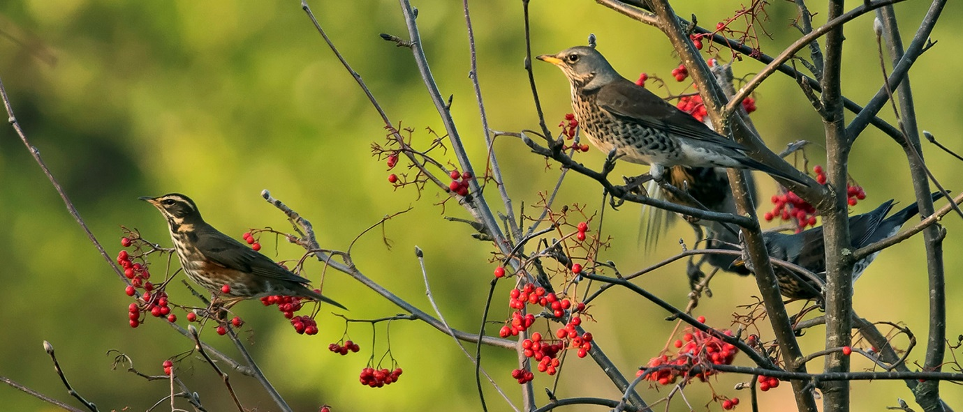
Redwing (left) and Fieldfare (right) on Rowan berries between 8th and 9th holes
It was a mild and wet start to the winter, so mild that a Chiffchaff was in full song on the 2nd December, “chiff-chaffing” away alongside the tee on the 2nd hole.
The wet weather saw the introduction of fairway mats and flocks of Redwings and Fieldfares arrived to feed on the Rowan berries. Mixed flocks could be seen between the 8th and 9th holes and also on the Rowans near the 18th green; with so many birds regularly feeding all the berries had gone by Christmas.
Ring-necked Parakeets were still present as was a regular Buzzard again along the 9th hole, while Pied and Grey Wagtails were regular around the sewage works and on the 2nd and 17th holes. Two Nuthatches used our feeders outside the clubhouse on 21st and Great Spotted Woodpeckers were regularly heard and seen around the course.
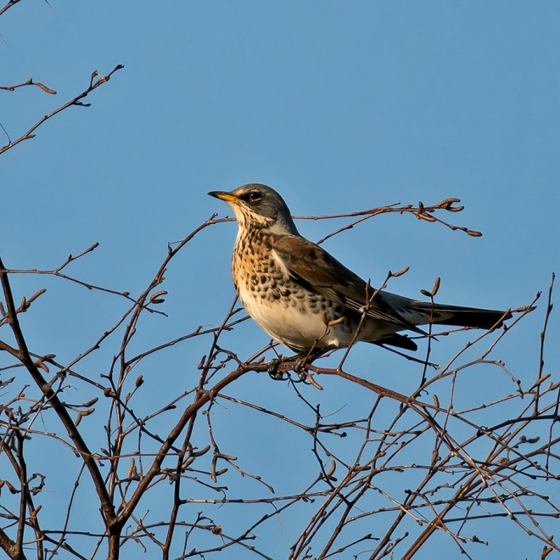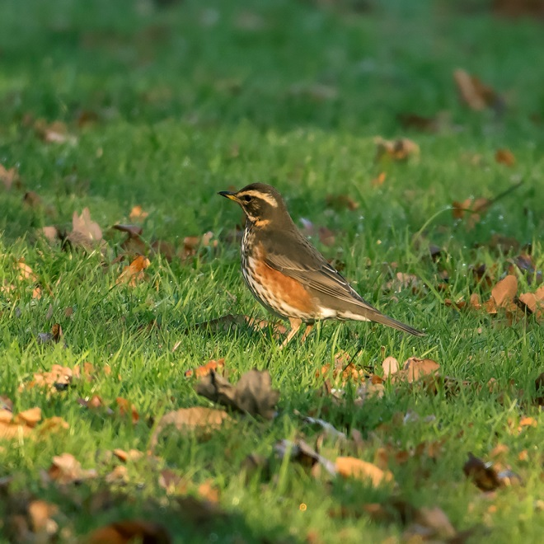
Fieldfare perched near the 18th green Redwing alongside the 11th fairway
January was a mix of cold and mild weather, but the cold dominated from mid-month; Mistle Thrush and Song Thrush were both in full song on 11th and 19th, while Robin (up to four birds), Nuthatch and Dunnock could still regularly be seen on the feeders outside the clubhouse. A Green Sandpiper was occasionally seen in flight heading towards the sewage works over the 12th tee; this has become a regular occurrence over the last few years.
A major surprise was a Fox seen mid-month on the practice ground and then on the 3rd green, hopefully it will survive in peace and quiet. Jay, Treecreeper, Buzzard and Great Spotted Woodpecker were all seen around the 9th green area on 19th of the month, when the Fox showed again running across the 9th fairway early morning.
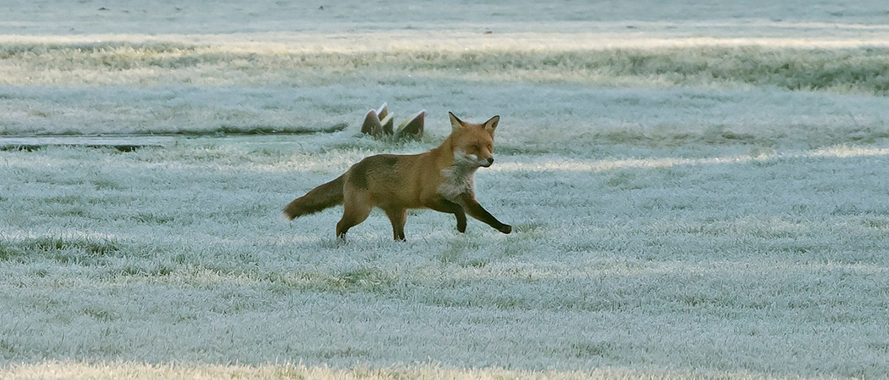
Fox in the frost: running past the 2nd tee on 23rd January
January ended with a variety of weather, from mega strong winds, to rain, hail, fog, frost and finally snow that closed the course on 30th January for five days.
The wildlife carried on regardless of the weather, with a male Pheasant (strangely very rare here) seen by the 3rd tee on 23rd, while the Fox was seen on and off, and two Ring-necked Parakeets flew over the 12th fairway on a daily basis. On 30th a female Shoveler flew from the ditch leading from the 1st pond then landed briefly in the pond before flying off into the distance; this is the first record for the course.
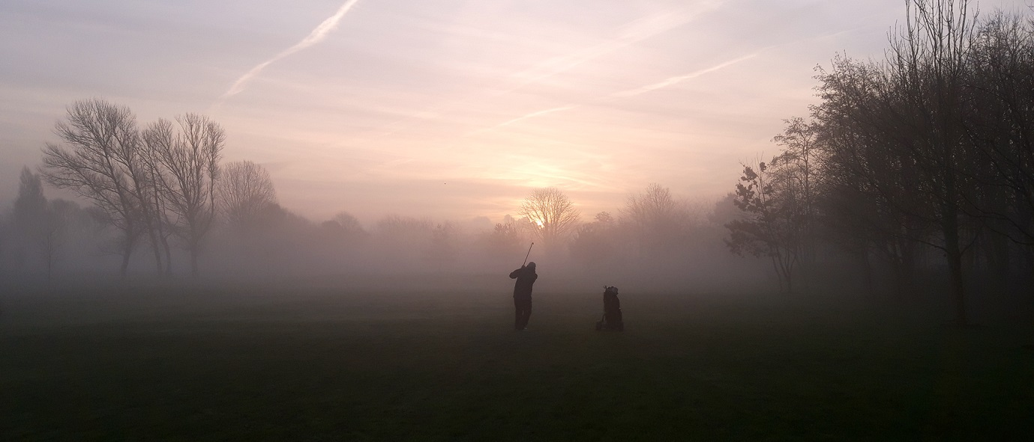
“What green”? If you can’t see it you can’t miss it…winter golf…ain’t it great….
A lovely spell of dry/mild weather mid-month allowing the course to dry out beautifully; the birds responded with Song Thrush and Chiffchaff particularly vocal, while Great Spotted Woodpeckers could be seen chasing each other through the trees and heard “drumming” on a daily basis, especially around 4th green area. It was hard to believe it had been so cold a couple of weeks ago.

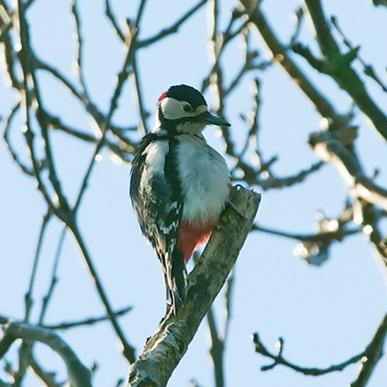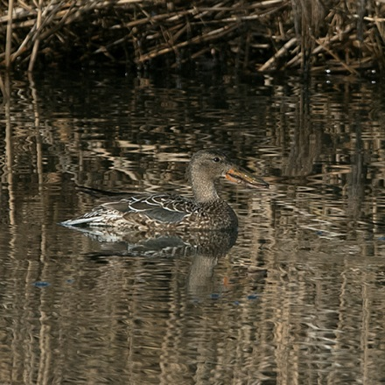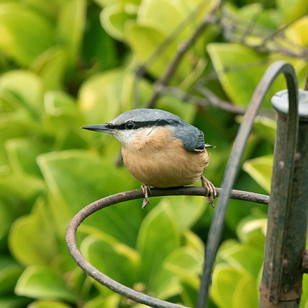
Great Spotted Woodpecker Shoveler (female) on 1st pond Nuthatch by the clubhouse
The weather continued to be mild and the month ended with an incredibly warm spell that saw members playing golf in t-shirts during February; the odd one was also noted in shorts…
The birds were now in full song with our Reed Bunting singing from the reeds in the 1st pond on 27th, while Skylarks could be heard in the fields along the 16th fairway. Coal, Blue and Great Tits were also heard and two Treecreepers were seen by the old practice net to bring the month to an end.
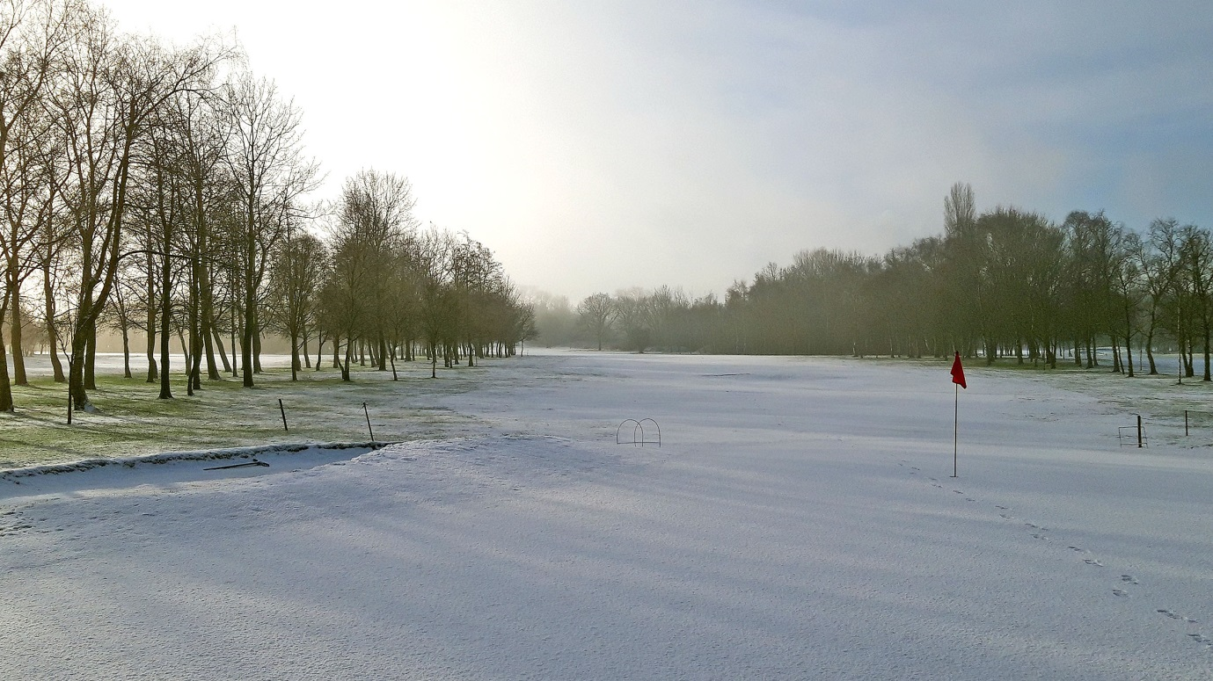
By the end of the month it was hard to remember this snowy spell in the first week of Feb

