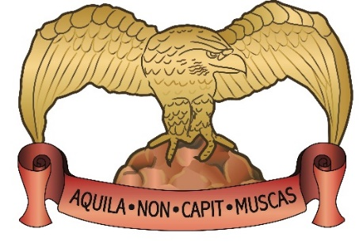
Sunday Lunch
St Mellons Golf Club CF32XS.
Call us on 01633680408 to book a table or drop into the members bar to speak with a member of staff.
Tables are available between 12-3pm

Example Menu, which will change each week.
Leek & Potato Soup (V)
Goujons of Plaice with Tartar Sauce
Herb Crust Brie Wedges with Spiced Tomato Chutney (V)
Chicken Liver Pate served with Toast & Chutney
****
Braised & Rolled Shin of Beef served with a Yorkshire Pudding
Pan Roast Breast of Chicken
Roast Loin of Pork with Sage & Onion Stuffing
Mushroom, Leek & Smoked Applewood Gratin (V)
(All Served with Seasonal Vegetables & Roast Potatoes)
****
Sticky Toffee Pudding with Butterscotch Sauce & Vanilla Ice-cream
Warm Chocolate Brownie with Chantilly Cream
Fresh Fruit Meringue with Raspberry Coulis
Lemon Posset served with Almond Shortbread
****
Tea/Coffee £1.95
1 Course £8.95
2 Courses £11.95
3 Course £13.95
(Please advise of any Dietary Requirements - We Cater for all)

