East Cork Golf Club – US Masters Buster Augusta National (April 11th to April 14th)

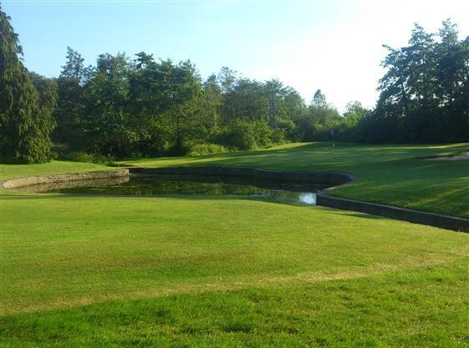
Competition Rules:
- Choose 5 golfers that you think will contend. Predict the top European and the winning score (The winning score will only be used in the event of a tie)
- Cost of Entry is €10 per person
- Entries to be submitted by Wednesday April 10th

YOUR PREDICTIONS |  |  | YOUR DETAILS
Golfer 1: |  |  | Name
Golfer 2: |  |  | Phone
Golfer 3: |  |  | ECGC Rep
Golfer 4:
Golfer 5:
Top European:
Winning Score:

Competition Points Scoring:  - Each Golfer that makes the cu  - Lowest Daily Score  - Top European  - Winner  - Runner Up  - Third  - Fourth  - Fifth | t 20PTS 30PTS  40PTS  100PTS  70PTS  50PTS  40PTS  30PTS | Last 6 winners of US ftasters:  - 2018: Patrick Reed, -15  - 2017: Sergio Garcia, -9  - 2016: Danny Willet, -5  - 2015: Jordan Spieth, -18  - 2014: Bubba Watson, -8  - 2013: Adam Scott, -9

Prizes: 1st Place €400. 2nd Place €250. 3rd Place €150. 4th + 5th Place €100 each, PLUS a variety of spot prizes.

Daily updates will be available on the East Cork Golf Club Facebook Page

US Masters Entrants @ Mar 6th 2019
Name | Odds |  | Odds | Name | Odds
Johnson, Dustin | 12 | Oosthuizen, Louis | 100 | Bling, Devon | 500
McIlroy, Rory | 12 | Li, Haotong | 100 | Rebula, Jovan | 500
Woods, Tiger | 15 | Simpson, Webb | 110 | Kanaya, Takumi | 500
Rose, Justin | 15 | Poulter, Ian | 140 | O'Connell, Kevin | 500
Thomas, Justin | 17 | Stenson, Henrik | 140 | Ortiz, Alvaro | 500
Spieth, Jordan | 18 | Hatton, Tyrrell | 160 | Hovland, Viktor | 500
Rahm, Jon | 20 | Kim, Si Woo | 170 | Cink, Stewart | 500
Fowler, Rickie | 25 | Cabrera-Bello, Rafael | 180 | Stanley, Kyle | 500
Koepka, Brooks | 25 | Howell III, Charles | 190 | Kim, Michael | 600
DeChambeau, Bryson | 25 | Willett, Danny | 190 | Bjerregaard, Lucas | 600
Day, Jason | 30 | Hoffman, Charley | 200 | Tway, Kevin | 700
Casey, Paul | 40 | Bradley, Keegan | 200 | Long, Adam | 750
Watson, Bubba | 40 | Fitzpatrick, Matthew | 200 | Na, Kevin | 750
Scott, Adam | 40 | Johnson, Zach | 200 | Kizzire, Patton | 800
Finau, Tony | 40 | Olesen, Thorbjorn | 200 | Immelman, Trevor | 800
Mickelson, Phil | 45 | Aphibarnrat, Kiradech | 200 | Couples, Fred | 850
Matsuyama, Hideki | 50 | Wallace, Matt | 200 | Cabrera, Angel | 1000
Fleetwood, Tommy | 50 | Noren, Alex | 210 | Singh, Vijay | 1000
Leishman, Marc | 50 | Grace, Branden | 220 | Langer, Bernhard | 1000
Reed, Patrick | 50 | Schwartzel, Charl | 220 | Lyle, Sandy | 1000
Smith, Cameron | 50 | Horschel, Billy | 230 | Mize, Larry | 1000
Schauffele, Xander | 55 | Snedeker, Brandt | 300 | Olazabal, Jose Maria | 1000
Molinari, Francesco | 60 | Lowry, Shane | 300 | Kodaira, Satoshi | 1000
Garcia, Sergio | 65 | Holmes, JB | 300 | Weir, Mike | 1000
Kuchar, Matt | 80 | Pepperrell, Eddie | 300 | Woosnam, Ian | 1000
Cantlay, Patrick | 90 | Walker, Jimmy | 400 | O'Meara, Mark | 1000
Woodland, Gary | 90 | Kaymer, Martin | 420

** Note: In the event that one of your players does not participate, the competition committee will automatically assign the top ranked next available player for you

