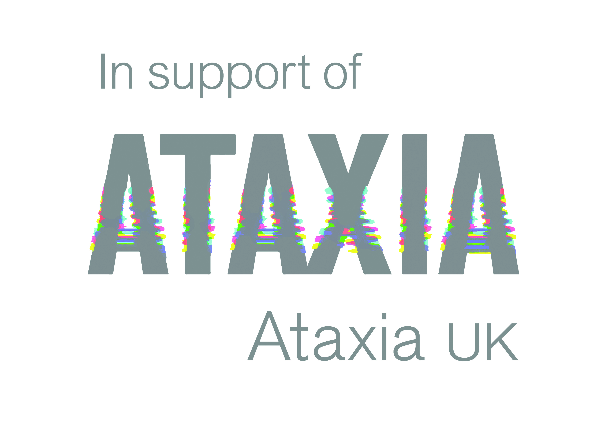
Charity AM-AM
Friday 9th August 2019
Type | Fee | Number required
Team Entry (includes coffee, bacon roll and 2 course meal after play) | £140
Team Entry + hole sponsorship | £240
Team Entry + Nearest the Pin/ Longest Drive Sponsorship | £190

Please complete this form and return complete with payment to Peter Rulton c/o The Herefordshire Golf Club, Raven’s Causeway, Wormsley, Herefordshire, HR4 8LY. Any enquiries to Peter at prultonbooks@aol.com or 07855832888.
Name…………………………………….….………….. Team Name…………………………………………………………………………….
Address………………………………………………………………………………………………………………………………………………………
………………………………………………………………………………………………………………….Postcode…………………………………
Tel No:………………………………………………Email address………………………………………………………………………………….
Team Members…………………………………………………………………………………………………………………………………………
Club…………………………………………………………………Preferred Tee Time…………………………………………………………..
We would like to keep in touch regarding club news, competitions and offers please tick to let us know you are happy to receive club & 3rd party promotions.
Club marketing emails: These are emails containing club information and may include social nights, functions and offers.
3rd Party marketing: These are emails that may include special offers from local businesses.

