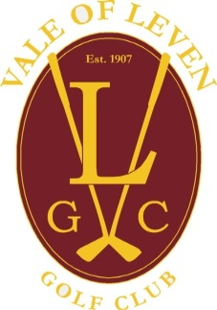

Northfield Course, Northfield Road, Bonhill, Alexandria, West Dunbartonshire, G83 9ET
Telephone: 01389 752351
E-Mail secretary@volgc.org. Website: www.volgc.org

MEMBERSHIP APPLICATION FORM

TO THE CAPTAIN & MEMBERS OF THE COUNCIL
I herby submit my application for membership of the club and agree to abide by the rules and regulations if accepted.
In the case of new members, payment of annual subscription are due on election.” Payment Methods: (1) annually one off payment, (2) 12 monthly direct debits.

Please use BLACK ballpoint pen & write in BLOCK CAPITALS.
CLASS OF MEMBERSHIP APPLIED FOR ____________________________________
Relationship (Associate Member Applications only)
Title: _____ Full Name: ____________________________________________________________________
Address:________________________________________________________________________________
________________________ Post Code __________ Home Phone No. ____________________________
Contact No. Daytime _______________________________ Mobile _______________________________
Email Address __________________________________
Do You Hold a Handicap at Any Other Golf club Yes……. NO…… If Yes What is your Handicap………
If Yes At What Club____________________________________________________________
Signature…………………………………….Date …………………………Date of Birth……………………..
nature ______________________________________________

JUNIOR MEMBERS ONLY.

I agree with my Son/Daughter’s Application for Membership and will be Responsible for Payment of Their Annual Subscription in Accordance with the Club Rules, During the Whole Their Junior Membership

Parent/Guardian Name ______________________________________________

Signature ______________________________________________ Date______

