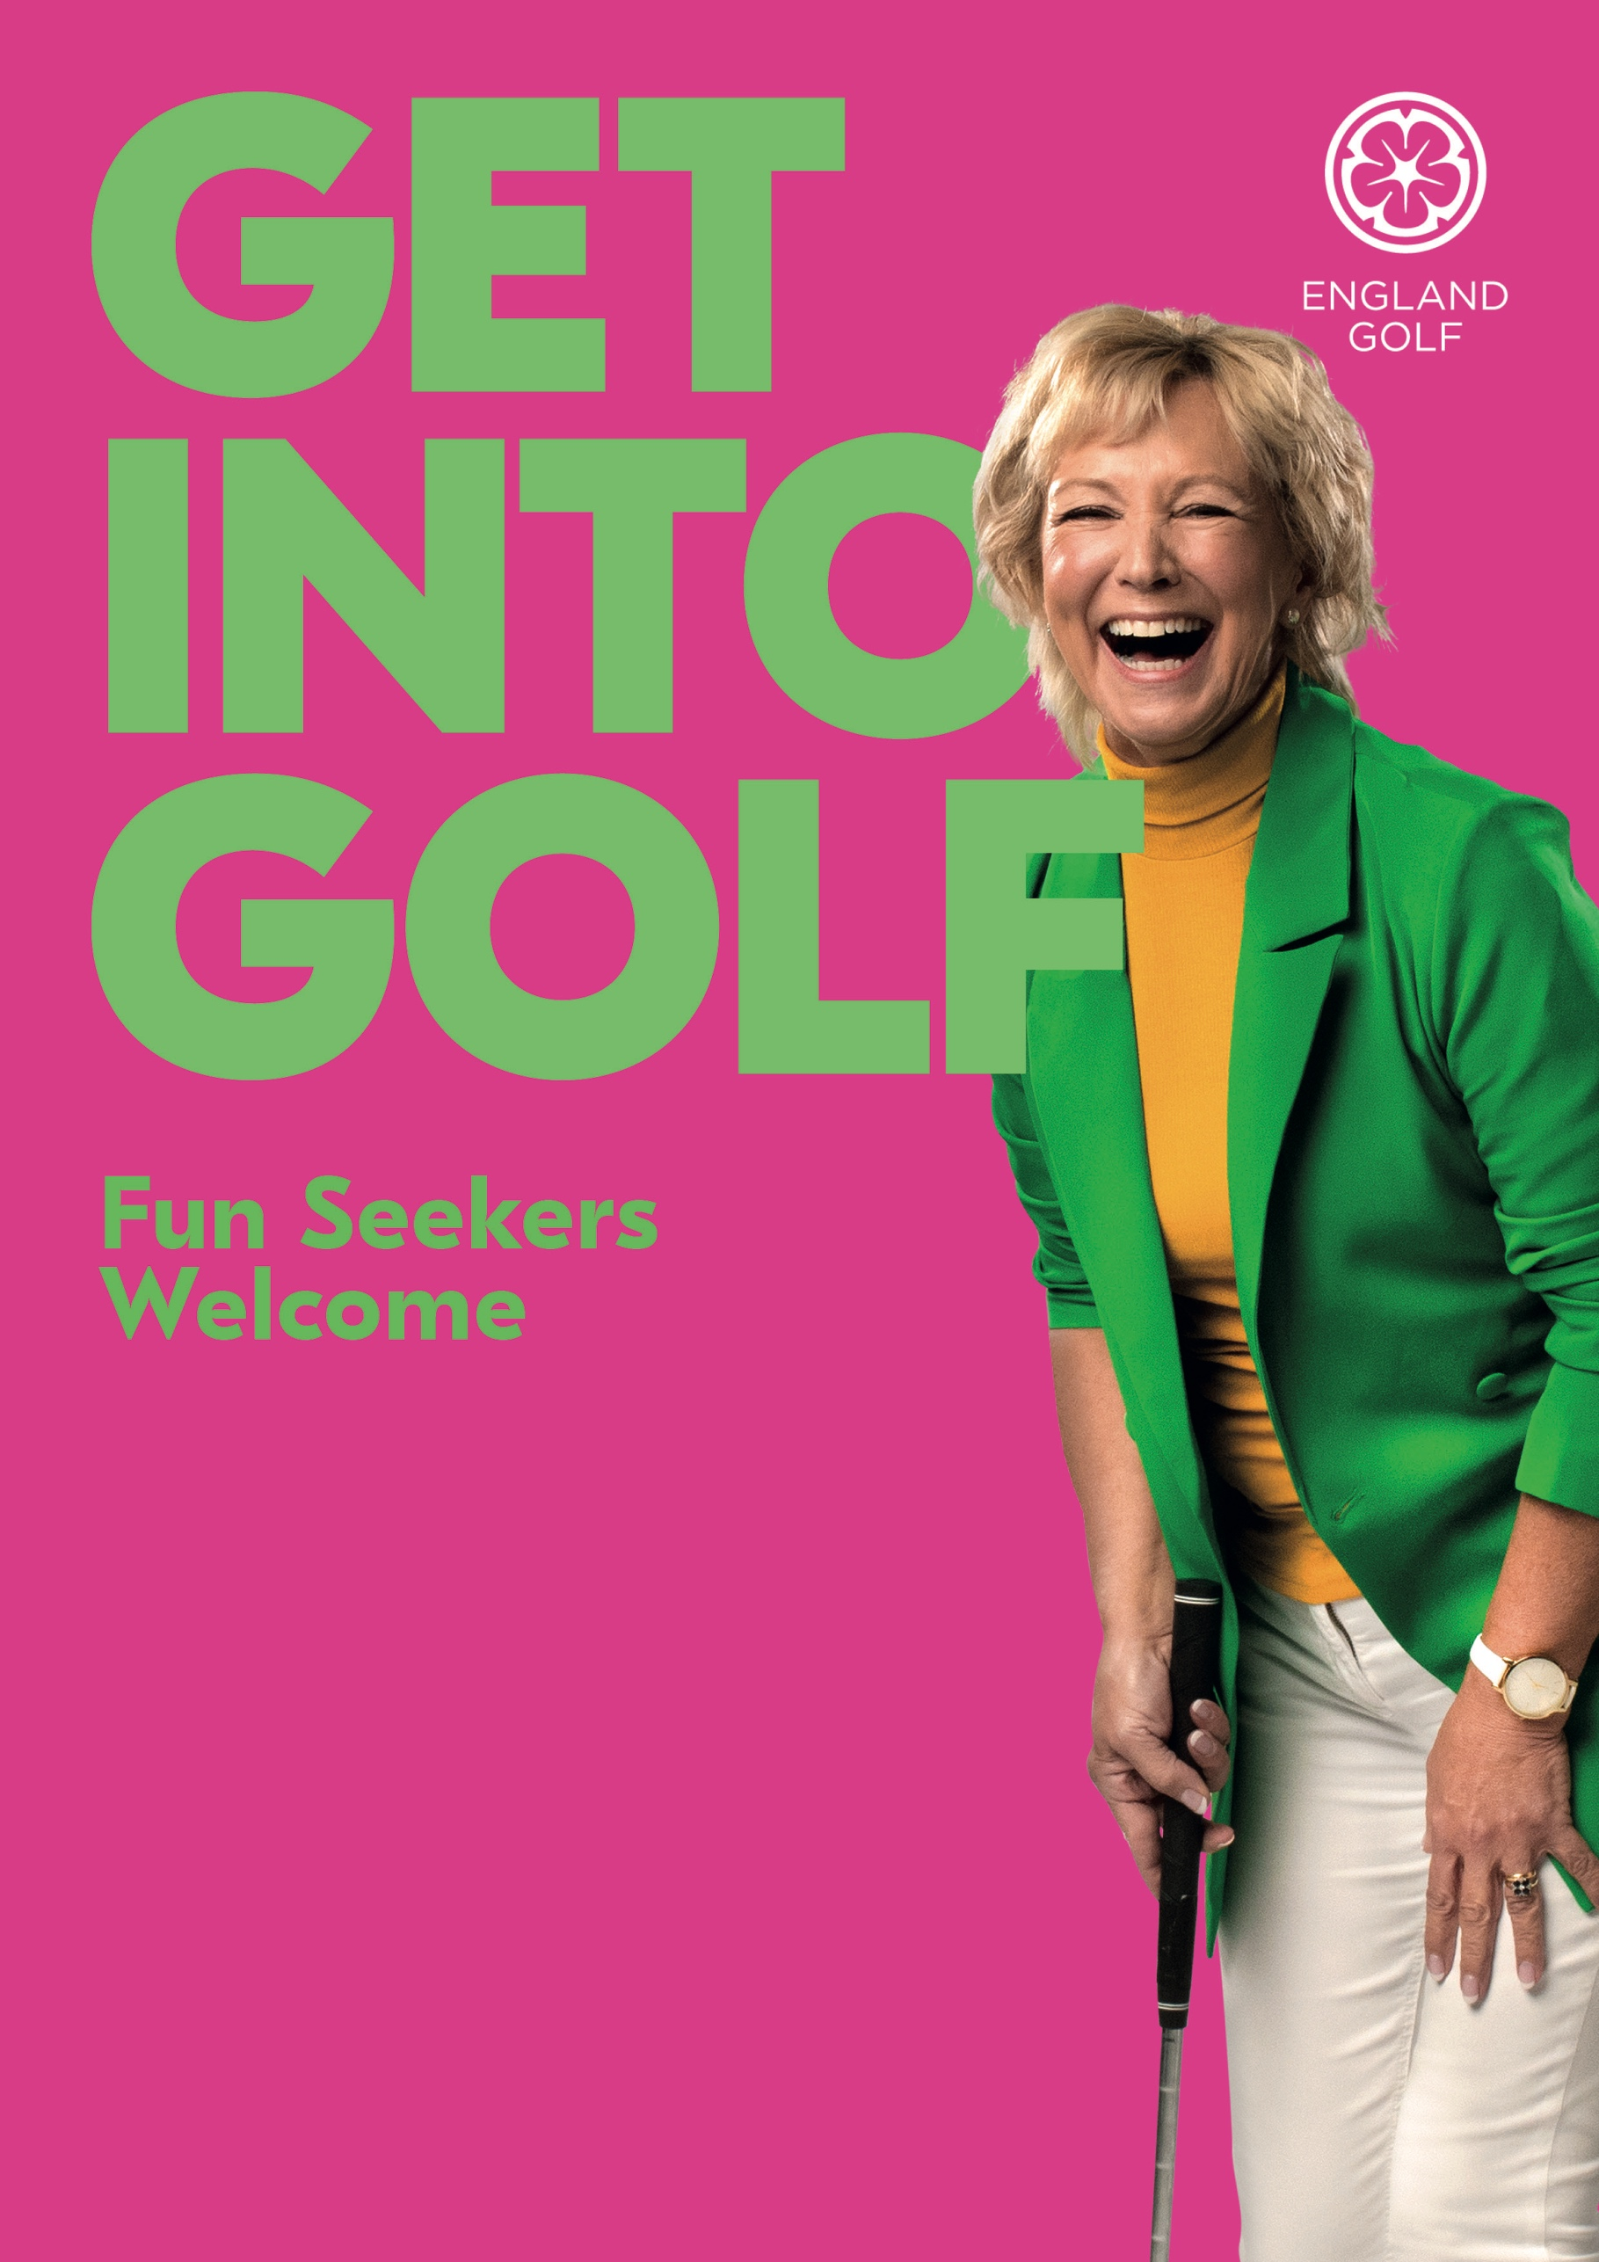

Boldon Golf Club

0191 5365360

Join us for an informal introduction to golf at Boldon Golf Club

Ladies & Girls Get into Golf Taster Session

Saturday 14th April

10am till noon