URVGC March Newsletter
New Captains message
As I stated in my speech at the Presentation Night I am delighted and honoured to become your Captain for the next year and look forward to representing you to the best of my ability.
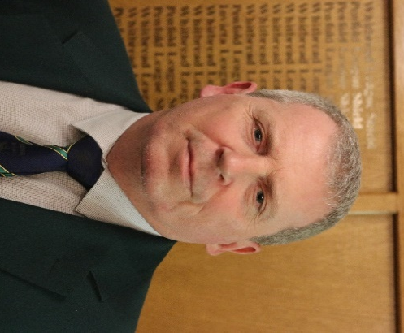
This is my first attempt at a Newsletter and I hope you find it useful and informative. If anyone has any suggestions on content for future months, please let me know. For those that don’t yet know what I look like please see here.

Captains Charity
For those that were not at the presentation night my designated charity this year is the Alzheimer’s Society. We made an excellent start to raising money for this cause at the presentation night as the raffle raised well over £500. Thanks to all those that bought tickets.
Presentation Night.
The Presentation Night took place on 3rd February and was attended by over 120 people. Congratulations to all those that picked up trophies from all the different sections. The outgoing Captain Dusty presented a cheque for £7'500 to his charity Prostrate cancer. Thanks to Dusty for all his hard work as Captain over the last year, he will be a hard act to follow. Greg our Secretary took loads of pictures of the night and they can be viewed by clicking on the link below https://goo.gl/LvkiWX
(look out for the one of Dusty standing next to our Ladies Captain Ellie).
The Course
The course despite being under several inches of snow over the past 10 days has recovered remarkably well and on Tuesday 6th the only temporary green was on the 9th.
Spring Maintenance on the Greens is due to start week commencing 12th March and this will mean that for a number of days the majority of holes will be on temporary greens. It will also mean that once we return to the normal greens that they are likely to be a bit sandy and bumpy for a few weeks. However, as we know in the longer term this will pay dividends.
Materials for the new base for the course toilet have been delivered and once this has been laid by the green staff the toilets themselves will be refurbished by Steve Noble.
New Rules of Golf
There has been much anticipation around the new rules of golf for 2019. It is our intention to implement a few of the upcoming new rules this year. The new dropping from knee high, only having 3 minutes to search for a ball and leaving the flag in when on the green will all be adopted by the club this year, please watch the website and club notice board for when they are to be implemented.
Competitions Results in February
Presidents Cup
This was held over the weekend of 10th and 11th February. The format for the completion was Greensomes. There was good weather for the time of the year on both days and the scoring was impressive. Below is the result.
1st P Wyatt and S Clarke 42 pts
2nd J Hemington and J Beautridge 41 pts
3rs M Henneker and T Verrall 38 pts

February Men’s Monthly Medal

Over the weekend 3rd and 4th of February, we had the monthly medal which attracted golfers. The results were as follows:

Saturday

Division 1

1st Lee Adgie Net 68
2nd Fred Wood Net 70
3rd Alan Morgan Net 71

Division 2

1st Chris Brown Net 69
2nd Chris Salt Net 72
3rd Adebayo Jacobs-Amoo Net 74

Sunday

Division 1

1st Darren Clinton Net 73
2nd Trevor Sharp Net 74
3rd Peter Friend Net 75

Division 2

1st Bill Powell Net 75
2nd Steve Wren Net 76
3rd Tim Sharp Net 77

Quarterly Stableford

Saturday 24th

Division 1

1st Marc Seager 39 pts
2nd George Cannon 37 pts
3rd Peter Winkworth 37 pts

Division 2

1st Peter Cregan 38 pts
2nd John Hemington 34 pts
3rd Dave Marsh 34 pts

Sunday 25th

Division 1

1st Steve Noble 34 pts
2nd Trevor Sharp 34 pts
3rd Peter Ribbens 31 pts

Division 2

1st Tony Pereira 36 pts
2nd Frank Hazell 35 pts
3rd Martin Gurney 34 pts

Well done to everyone who participated and I note a few handicap reductions will have been issued by the Secretary!

March Men’s Monthly Medal

This was due to take place on 3rd and 4th March but was cancelled due to the snow.

This has now been rescheduled for the weekend of 31st Marc and the 1st April.

Junior’s Monthly Medal

Nathan Jeffery won the Junior Medal on the Saturday with a Net 78, with Archie Johnston 2nd with a net 79, Harry Mendoza was 3rd with a net 80.

Ladies Section Activities during February
Ladies February medal results were as follows:
1st Clare Eastwood Net 75
2nd Hollie Heasman Net 83
3rd Joanne Kyte Net 84
Veteran’s Section
February Medal Div1
Dave Marsh nett 63
Dennis Sweeney nett 65
Martin Henneker nett 66
Div 2
Mick Smith-Kerr nett 68
Raymond Langham nett 68
Ron Simmonds nett 69
Vets Texas Scramble
1st A Wells, A Jull, J Heppeler Net 57
2nd G Drake, R Jeffery, R Liddell Net 57
3rd S Wren, T Jones, I Beattie-Burrows Net 57.2

Veterans Invicta League
The 1st League Match is on Tuesday 27th March at home against Pedham Place

Whitbread League

The 1st League Match is on Saturday 24th home against Lullingstone

Up and Coming Competitions in March and April
March 17th St Patrick days Texas Scramble shotgun start.
March 20th Veterans Monthly Medal
March 25th Captains Drive in
March 27th Veterans Quarterly Stableford. Ladies Greensomes
April 3rd Veterans Monthly Stableford
April 7th Men's Monthly Medal, Juniors Monthly Medal
April 8th Men's Monthly Medal, Ladies Monthly Medal
April 10th Veterans Yellow ball Stableford. Ladies Monthly Medal
April 15th Ladies Spring Meeting
April17th Veterans Monthly Medal. Ladies Spring Meeting
April 19th Men's Midweek Medal
April 21st Adult/Junior cup
April 22nd St Georges Day. Texas Scramble Shotgun Start.
April 24th Veterans Team Stableford
April 28th Men's Medal Winners
April 29th Men's Medal Winners, Ladies Monthly Medal

Good luck to everyone this golfing year, I look forward to seeing you all on the course and in the bar.

Jeff Beautridge
URVGC Captain 2018

