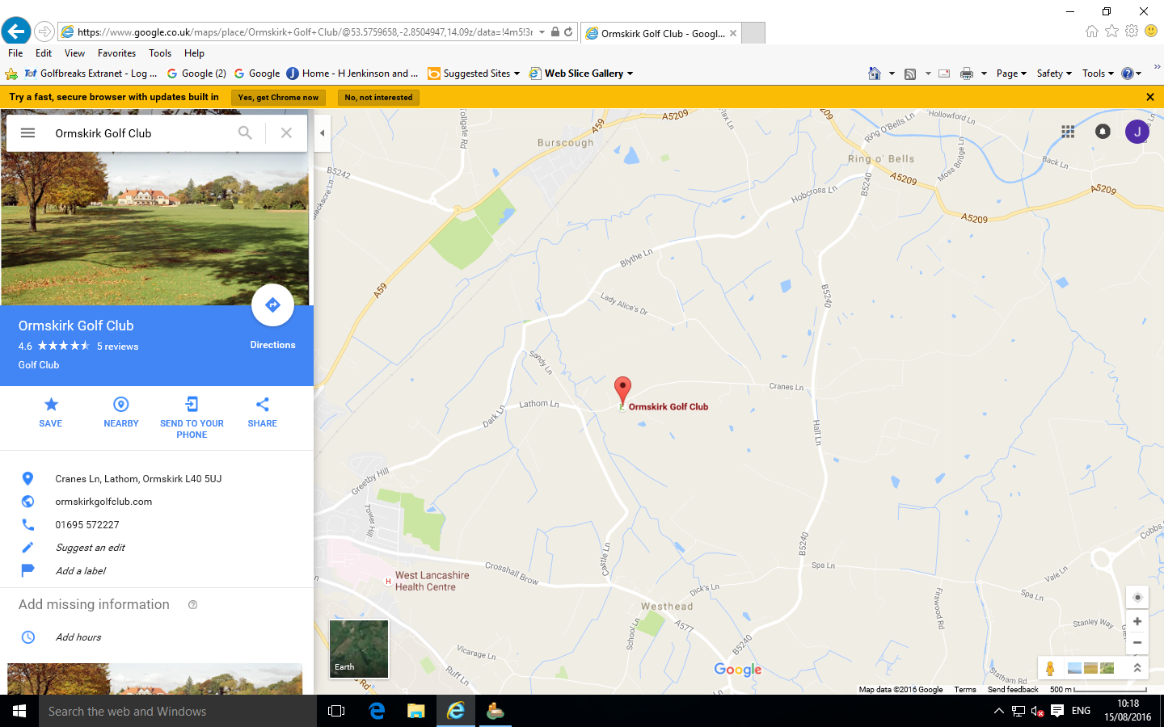

Halton Castle

From the M6

From M58

Do Not Enter Cranes Lane at this end.