- Download the PDF application form from (http://www.bonnybridgegolfclub.co.uk/page.aspx?pid=24056)
- Fill out application form, using the boxes provided.
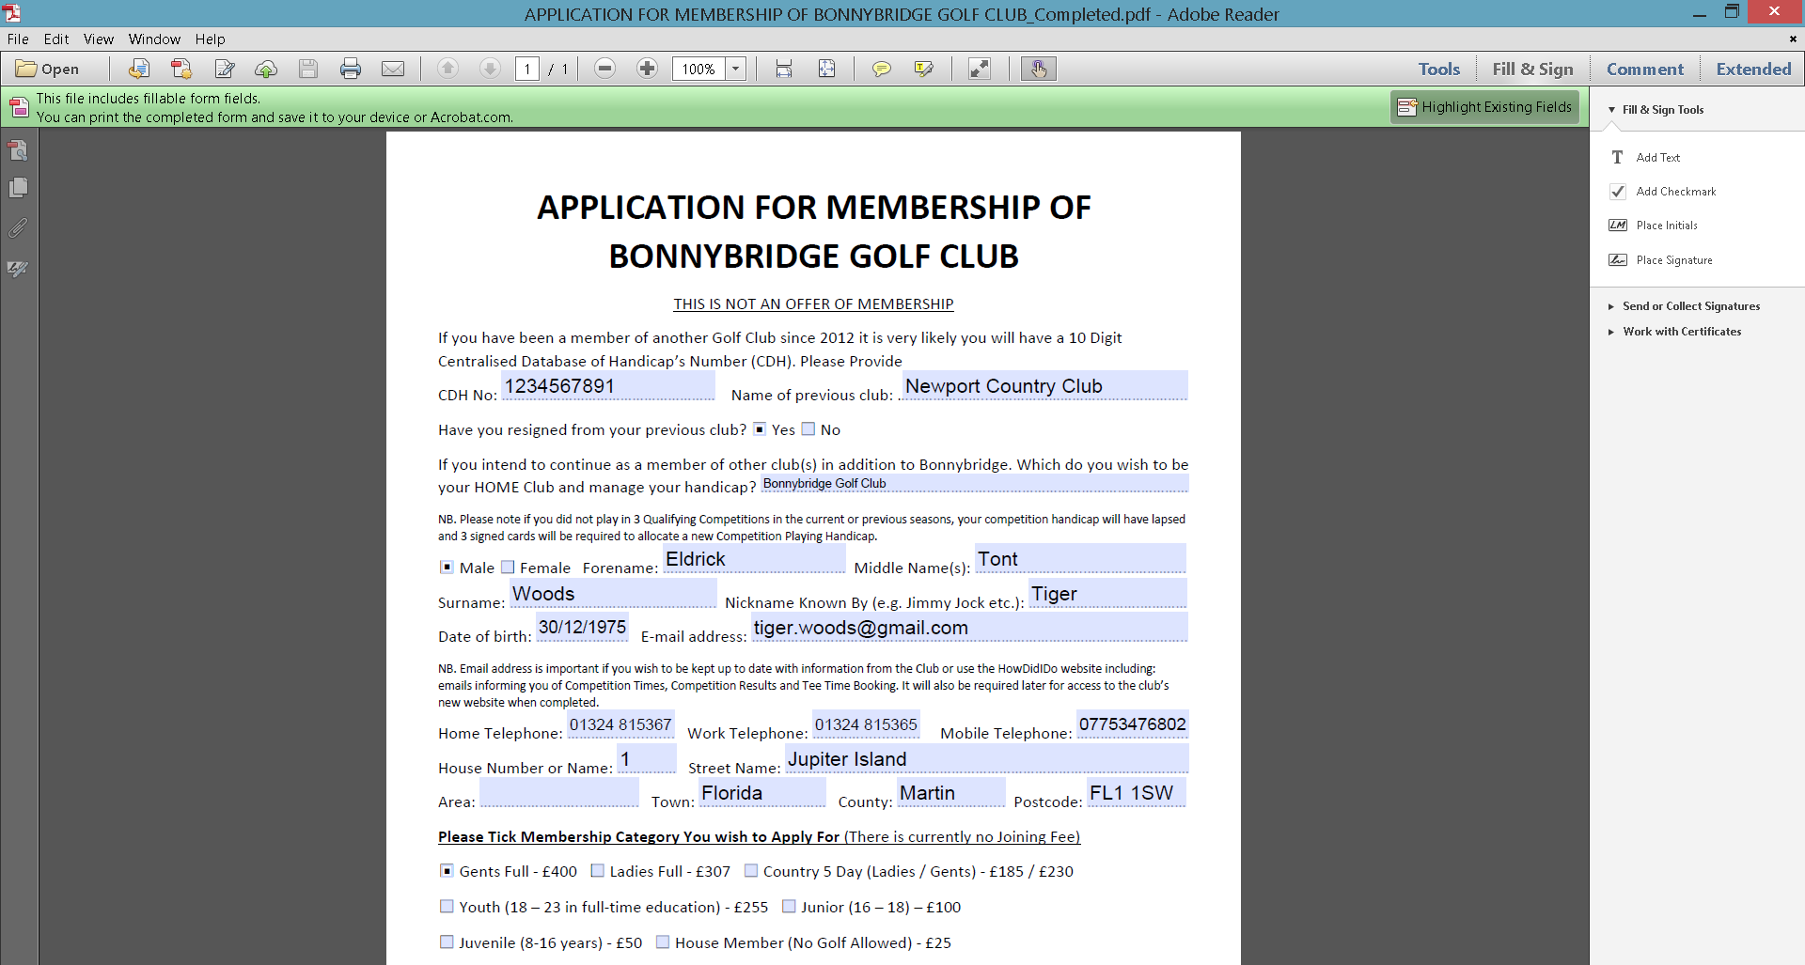
- Click the File, and then click Save.
- Choose an appropriate directory, click Save.
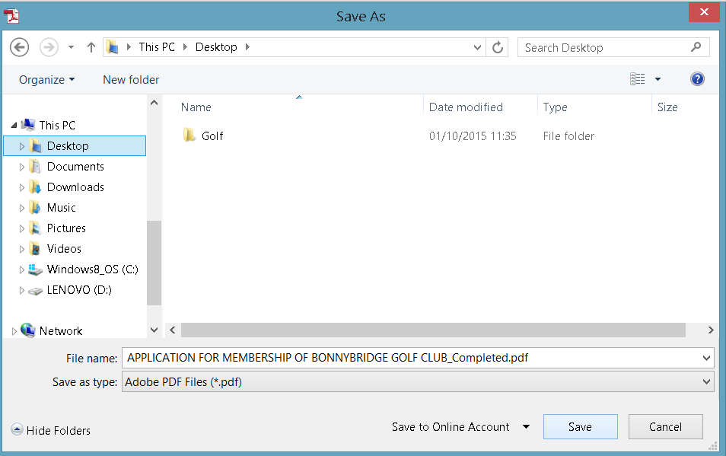
- Email the completed document to bgc1925@hotmail.co.uk.

