Competition Entry via How Did I Do.

This is only possible if you are registered with www. Howdidido.co.uk. If you are not registered, then you will need to visit the club house and enter the competition via the TFI terminal in the Gents Locker Room.

Step 1
Log into www.howdidido.co.uk and from the quick links menu on the right hand side of the page, click on the My Clubs link.
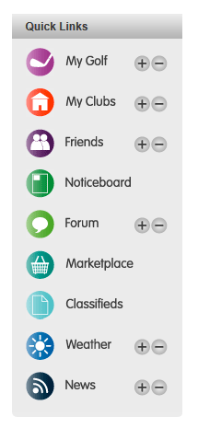

Step 2

On the menu on the left hand side of the Kinross Golf Club page, click the Start Sheets Link

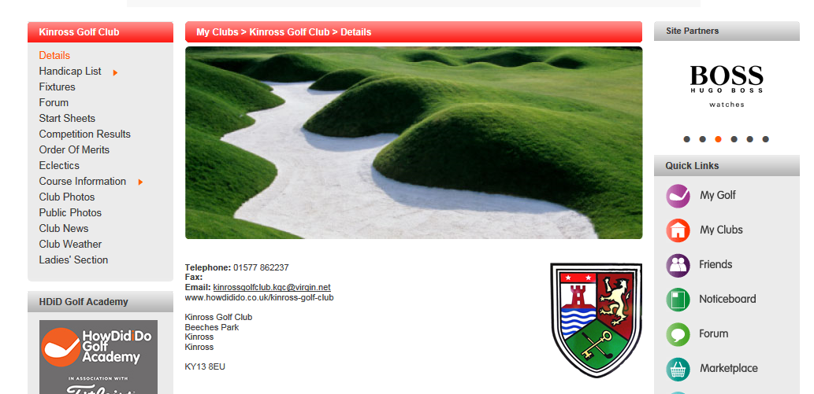
Step 3

Select the competition from the list that appears.

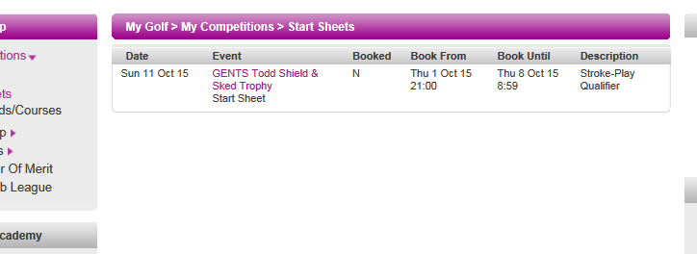

Step 4

The competition entry sheet will now be displayed. Select the desired tee time by clicking on the relevant cell. If you are unable to select the cell, then it is possible that the competition is not yet open for entry. The date and time at which you are able to enter online will be shown at the left hand side of the page.

If the tee time is available, you will receive a message confirming that the time is booked and your name will appear in the relevant cell.

PLEASE NOTE – THIS DOES NOT GUARANTEE THAT YOU WILL TEE OF AT THIS TIME, AS THE ACTUAL TEE TIMES WILL BE SUBJECT TO A RANDOM DRAW (ON A THURSDAY) IN THE SAME BLOCKS OF TEE TIMES (IN LINE WITH THE USUAL PRACTICE).

PLEASE CHECK THE CLUB WEBSITE, NOTICEBOARD, OR WITH THE PRO-SHOP TO CONFIRM THE ACTUAL TEE TIME ALLOCATED.

